Project ID
46



Project Report On
GYM PRO – GYM MANAGEMENT SYSTEM
Submitted in the Partial fulfillment of the requirement for awarding the degree of Bachelor of Computer Application (BCA)
SEM V, Year 2025

By
Rathod Nenshi
Nandaniya Pal

Under the Guidance of
Prof. Ishita Mem

DEPARTMENT OF COMPUTER SCIENCE
LATE P.S. HIRAPARA MAHILA BCA COLLEGE JETPUR
Affiliated to
SAURASHTRA UNIVERSITY - RAJKOT

Preface

This report contains all the outputs of a project undertaken to develop a working model of GYM PRO – Gym Management System and to study the existing working system. As part of this study, we analyzed the requirements of the working model and tried to improve it using the technological functionality that the current computer science provides.
This volume contains the documentation summary of the working system, the background study and analysis, the technical requirements and the working specification of the developed system.
We recommend the user to take the advantage of the study presented here and implement the system with their required improvisation. We hope this study will reduce the burden of the reanalysis of the development phase.

Acknowledgment

“It is not possible to prepare a project report without the assistance & encouragement of other people. This one is certainly no exception.”

On the very outset of this report, we would like to extend our sincere & heartfelt obligation towards all the personages who have helped us in this endeavor. Without their active guidance, help, cooperation & encouragement, we would not have made headway in the project. We are ineffably indebted to our HOD / Prof. Jitendra Kabariya for conscientious guidance and encouragement to accomplish this assignment.

We are extremely thankful and pay our gratitude to our project guide Prof. Ishita mem. her valuable guidance and support on completion of this project in it’s presently.

We extend our gratitude to Department Of Computer Science, Late P.S. Hirapara Mahila BCA College-Jetpur for giving us this opportunity.

Thanking You
Student -1 Rathod Nenshi (24CS002UG05309)
Student -2 Nandaniya Pal (24CS002UG05285)

INDEX

- Front Page
- Certificate
- Preface
- Acknowledgement
Sr. No. | Title |  | Page No.
1 | Project Profile
 | 1.1 | Project Definition
 | 1.2 | Scope
 | 1.3 | Objective
 | 1.4 | Technical Description
2 | System Analysis and Specification
 | 2.1 | Study of Current System
 | 2.2 | Weakness of Current System
 | 2.3 | Introduction of New System
 | 2.4 | Hardware and Software Requirement
3 | System Requirement Specification
 | 3.1 | Proposed System and Advantages
4 | System Design
 | 4.1 | Use – case Diagram
 | 4.2 | Data Flow Diagram
 | 4.3 | E-R Diagram
 | 4.4 | Data Dictionary
5 | Screen Design
6 | Testing (Manual, Test Cases and Test Data)
 | 6.1 | Manual Testing
 | 6.2 | Test Cases
7 | Enhancements
 | 7.1 | Advantages
 | 7.2 | Limitation
 | 7.3 | Future Scope
8 | Bibliography

- Project Profile
1.1 Definition
GYM PRO – Gym Management System is a web-based software application developed to manage and maintain the daily activities of a gym. It helps the gym administrator manage member information, membership details, batches, trainers, attendance, payments and other gym-related records in a systematic and efficient way.
The system reduces manual paperwork, saves time, improves data management, and makes it easier to store, update, and retrieve gym information whenever required. It provides three separate, password-protected panels for the Admin, the Trainers and the Members, in addition to a public informational website for visitors.

1.2 Scope
The GYM PRO – Gym Management System is designed to manage gym members, memberships, batches, trainers, attendance and payments in an organized way. It reduces manual paperwork and makes daily gym management easier for the owner and staff.
The system helps the administrator to add, update, delete and view records easily. It saves time, reduces errors, and provides quick access to important gym information such as who is due for renewal, which batch is running short of trainers, and how much revenue has been collected.

1.3 Objective
The main objective of the GYM PRO – Gym Management System is to develop a simple and efficient system for managing gym activities and records. It aims to reduce manual work and make gym management faster, easier, and more organized.
The major objectives are to:
- Maintain accurate member and membership records.
- Manage batches, trainers, attendance and payment information.
- Allow a member to join more than one batch while automatically preventing any clash between the timings of the selected batches.
- Ensure no membership becomes Active without a logged or verified payment, by gating every new registration and renewal behind a payment step.
- Provide easy adding, updating, approving, deleting and viewing of records.
- Reduce paperwork and manual errors.
- Save time and improve the overall efficiency of gym management.

1.4 Technical Description

Technical Aspect | Description
Frontend | HTML, CSS, JavaScript
Backend | PHP
Database | MySQL

2. System Analysis and Specification
2.1 Study of Current System
Most small and medium gyms still manage their day-to-day operations manually. During the study of the existing system, the following observations were made:
- New member details, batch timings and fee amounts are written down in a membership register or note-book.
- Attendance of members is taken on a paper sign-in sheet kept at the reception desk.
- Trainers keep track of which members belong to which batch from memory or hand-written batch sheets pinned on a notice board.
- Renewal of a membership is tracked by checking a physical register or a diary maintained by the gym owner.
- Fee receipts are hand-written and a carbon copy or a simple cash-book is kept for accounts.
2.2 Weakness of Current System
The manual system currently followed by most gyms suffers from the following drawbacks:
- Registers can be lost, damaged, misplaced or duplicated, and there is no backup of the data.
- Checking whether a new admission's chosen time slot clashes with an existing batch is done manually and is error-prone; double-booking of a batch beyond its capacity is common.
- Retrieving a particular member's payment history or attendance record takes considerable time when done manually.
- There is no way for a member to check their own membership status, batch timing, attendance or dues without visiting or calling the gym.
- Sending renewal reminders or announcements to all members has to be done individually by phone or word of mouth, which is slow and unreliable.
- Trainers have no organized way to record attendance or maintain a workout plan for their batch.

2.3 Introduction of New System
GYM PRO – Gym Management System replaces the manual register with a centralized, web-based application. The new system introduces the following improvements:
- A public website lets any visitor view the gym's batches, trainers and gallery, and submit an online registration request; the Admin reviews and approves it, after which the member is created automatically.
- A member can join more than one batch at the same time, and the system automatically prevents the member from picking two batches whose timings overlap.
- Every new registration or renewal is payment-gated: the member is created with a 'Pending Payment' status and cannot reach their dashboard until a payment covering the amount due is logged by the Admin or verified online — this applies even when the Admin adds or renews a member directly.
- A member can pay online by scanning the gym's own UPI/QR code and submitting the transaction ID, which queues the claim for the Admin to verify before it is treated as a real payment; alternatively, the Admin logs the payment directly when it is collected in person.
- Registration now enforces a minimum age of 18 years, checked both on the date-picker and again on the server.
- Trainers mark attendance for their own assigned batches from their own login, and can maintain a simple workout plan for the batch.
A dashboard gives the Admin an at-a-glance view of active members, pending requests and revenue collected.

2.4 Hardware and Software Requirement (Feasibility Study)
FEASIBILTY STUDY

Feasibility study is the likelihood that whether the system will be useful to the organization or not. After studying the requirements, whether the proposed project is feasible or not is determined by checking the various feasibilities.

The main aim of the feasibility study is to determine whether developing system is financially and technically feasible. The feasibility study involves analysis of the problem and collection of data which would be input to the system, the processing required to be carried out on these data, the output data required to be produced by the system, as well as study of various constraints on the behavior of the system.
The three aspects in the feasibility study portion are:

- Technical Feasibility
- Economical Feasibility
- Operational Feasibility

Brief introduction of above 3 feasibilities is as under:

Technical Feasibility

Technical feasibility is considered in terms of technical requirements and their availability in the market. It determines whether the current level of technology supports the proposed system or not. The technical possibility of proposed system is as follow:
- Since the main aim of technical feasibility study is to determine whether unit possess the hardware as well as related software for the project.
- Proposed system does not require much technical detail.
- The current manual system is not so much sufficient for processing of all kinds of tasks.
- It needs low configuration computer system or high configuration computer system and the required operation system.
- It just required windows operating system.
- The organization is ready to purchase the entire required device, required by the proposed system.
- This technical specification is easily available in the market. Therefore the proposed system is technical feasible.

Technical feasibility is considered in terms of technical requirements and their availability in the market. It determines whether the current level of technology supports the proposed system or not. The technical possibility of proposed system is as follow.

In order to develop the web-application except some basic requirement there is no need of extra technology. Also no other workforce is required to develop the application. Yes, Internet is required but you can also run it off-line by sharing

Technical Feasibility

Hardware | Specification
Processor | 1 GHz or Higher Intel
Motherboard | Compatible with the processor
Hard Disk | 250 GB or More
RAM | 1 or 2 GB
Monitor | Any CRT/LCD/LED
SMPS | 450 Watt
Keyboard | Any Multimedia
Mouse | Optical
.

Software | Specification
Front End | HTML,PHP, CSS, JS
Back End | MySql Server
Browser | Any web browser (Preferable Mozilla Firefox, Chrome)
Operating System | Cross Platform (Windows, Linux, etc…)

ECONOMICAL FEASIBILITY

The economical feasibility is considered in terms of money or rupees value. The organization measures the cost effectiveness of the project. The economical feasibility of the proposed system is as under.

- The organization is ready to invest in the proposed system for latest technology and better result.
- As the personnel and the manager know the computer operating, the unit need not have to appoint any computer operator.
- If any of the staff in the firm knows how to operate the computer, than the firm needs number to recruit a new person.
- The unit has to spend not much amount for the computer hardware and software.
- The organization is capable for paying the money for proposed system.
- Therefore the project possesses the economical feasibility.

The economical feasibility is considered in terms of money or rupees value. It measures the cost effectiveness of the project. The economical feasibility of the proposed system is as under.

As it is an on-line application a minimal cost of web-hosting will be charged. But it will be affordable. There would not be any charge to have look to site off-line while under construction.

Economical Feasibility

Hardware | Specification | Price
Processor | Intel core i3 10th Gen | ₹ 8200
Motherboard | GA H110 | ₹ 6800
Hard Disk | Seagate BarraCuda 1 TB | ₹ 3400
RAM | DDR4 4GB | ₹ 850
Monitor | Dell 18.5” LED | ₹ 5800
SMPS | Circle 450 Watt | ₹ 1200
Keyboard | Logitech Wired keyboard | ₹ 750
Mouse | Logitech Optical USB | ₹ 350

Software | Specification | Price
Front End | HTMl, PHP, CSS, JS | Free
Back End | MySql Server | Free
Browser | Any web browser (Preferable Mozilla Firefox) | Free
Operating System | Microsoft Windows 10  Linux (Ubuntu) | ₹ 3500  Free

- Prices are approximately as per current year (2025)

Operational feasibility

Operational feasibility determines whether the proposed Gym Management System can fulfill the requirements of the gym and its users.

The system manages members, trainers, batches, attendance, payments, and memberships.

It reduces manual paperwork and makes data management easier.

Admins, trainers, and members can easily use the system with basic computer knowledge.

It provides quick and efficient access to gym information.

Therefore, the proposed Gym Management System is operationally feasible and beneficial for daily gym operations.

3. System Requirement Specification
3.1 Proposed System and Advantages
Based on the study of the current manual system and its weaknesses, the following project model (modules) is proposed for GYM PRO – Gym Management System:
1) Public Website
Provides Home, About, Batches, Gallery and Contact pages so that any visitor can learn about the gym before joining.
2) Visitor Registration
A visitor can register online by filling in personal details and choosing one or more batches. The system groups batches by time-of-day and blocks any selection whose timings overlap, before the request is sent for approval.
3) Admin Module
The Admin can manage members, trainers and batches; approve or reject registration and renewal requests; log in-person payments and verify or reject online payment submissions; post announcements; and view a dashboard of key statistics.
4) Trainer Module
A trainer can view the batches and members assigned to them, mark daily attendance, maintain a simple workout plan for the batch, and post announcements.
5) Member Module
A member can view their profile, batch(es), attendance and payment history; pay online via UPI/QR and submit the transaction ID when their status is Pending Payment; request renewal of an expiring membership; and view announcements posted by the Admin or trainer.

Advantages of the Proposed System
- Replaces scattered paper registers with a single, centralized, always-available database.
- Automatically prevents a member from being enrolled in two batches whose timings clash, which is not practically possible to check by hand.
- No membership can ever become Active without a logged or Admin-verified payment — the payment gate applies identically whether the member registered themselves or the Admin added them directly, closing a gap that manual systems cannot enforce.
- Lets a member pay online at their own convenience via UPI/QR, while still giving the Admin final control through a Verify/Reject step before any online claim is treated as real money received.
- Cuts down the time needed to search for a member's record, payment history or attendance from minutes to seconds.
- Gives every member and trainer self-service, read-only access to their own information, reducing the number of enquiries handled at the reception desk.
- Scales easily as the number of members, batches or trainers grows, unlike a paper register.

4. System Design
4.1 Use – Case Diagram
1.user
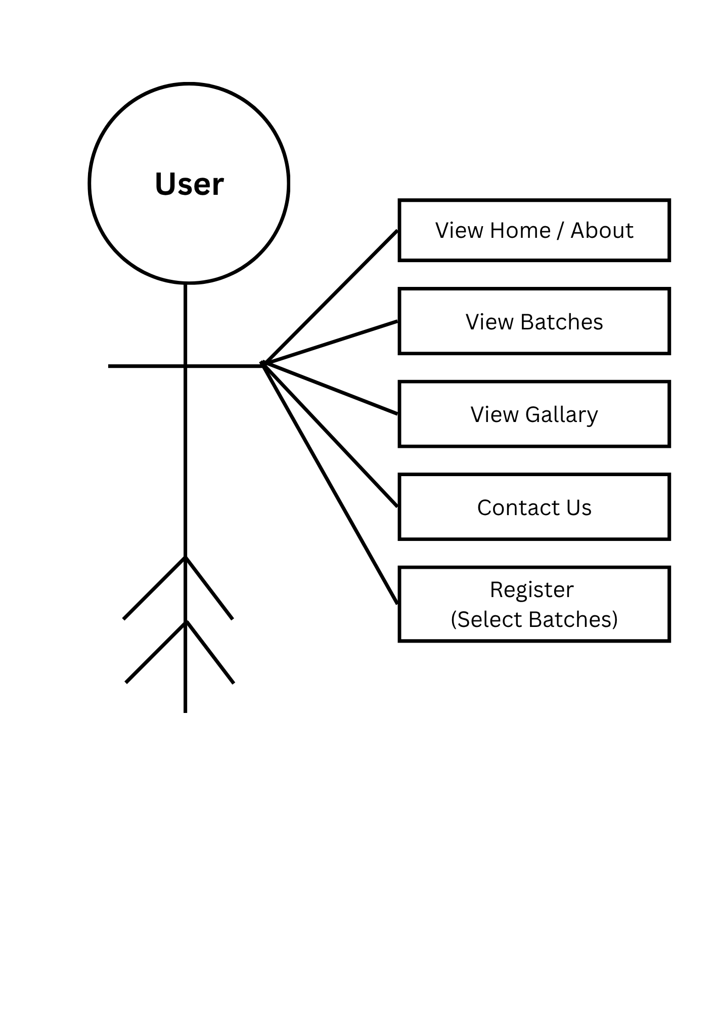

2. Member
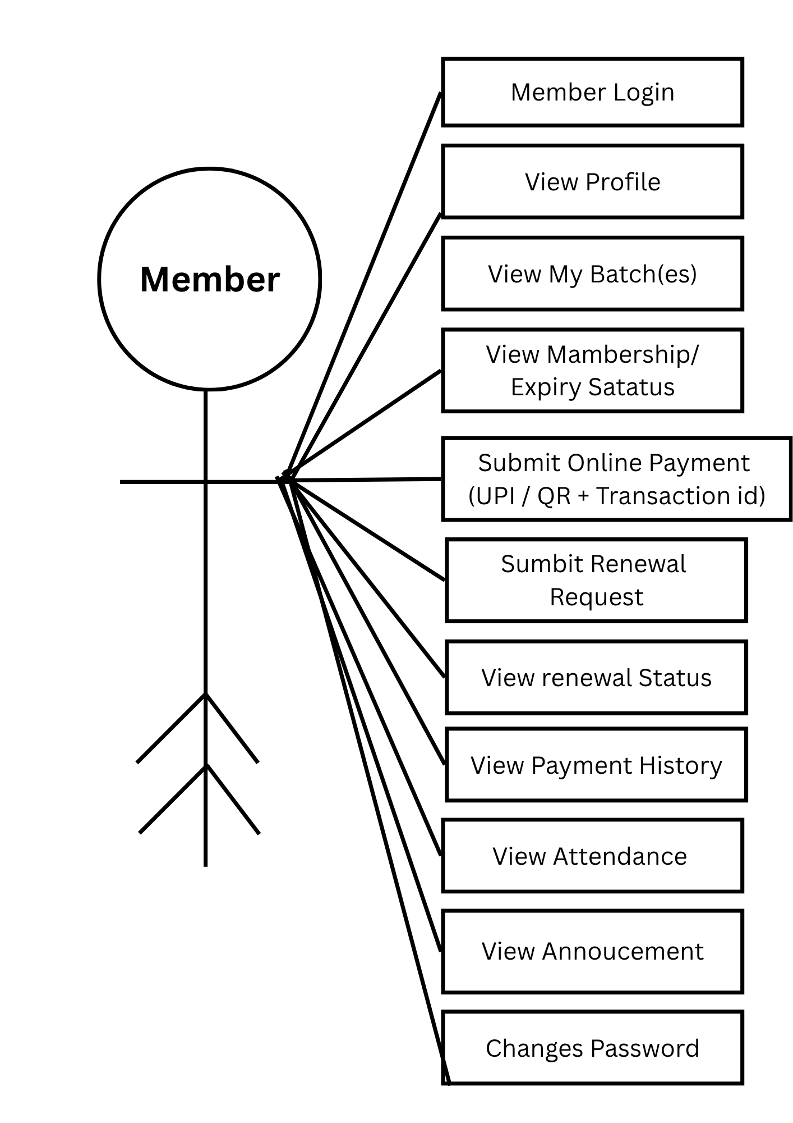
3. Trainer
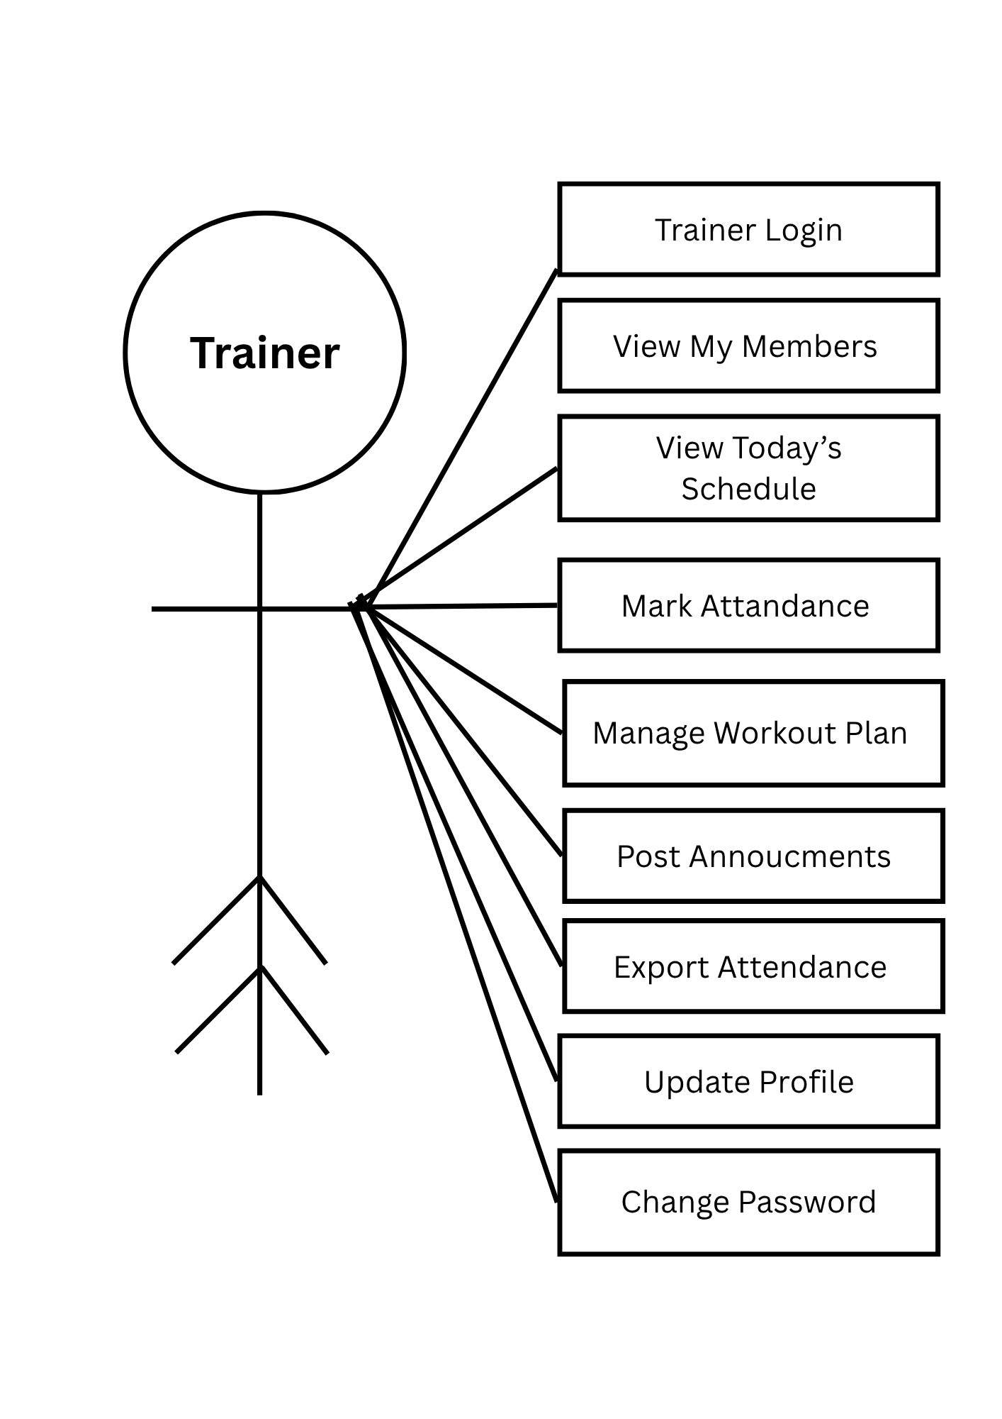

4. Admin
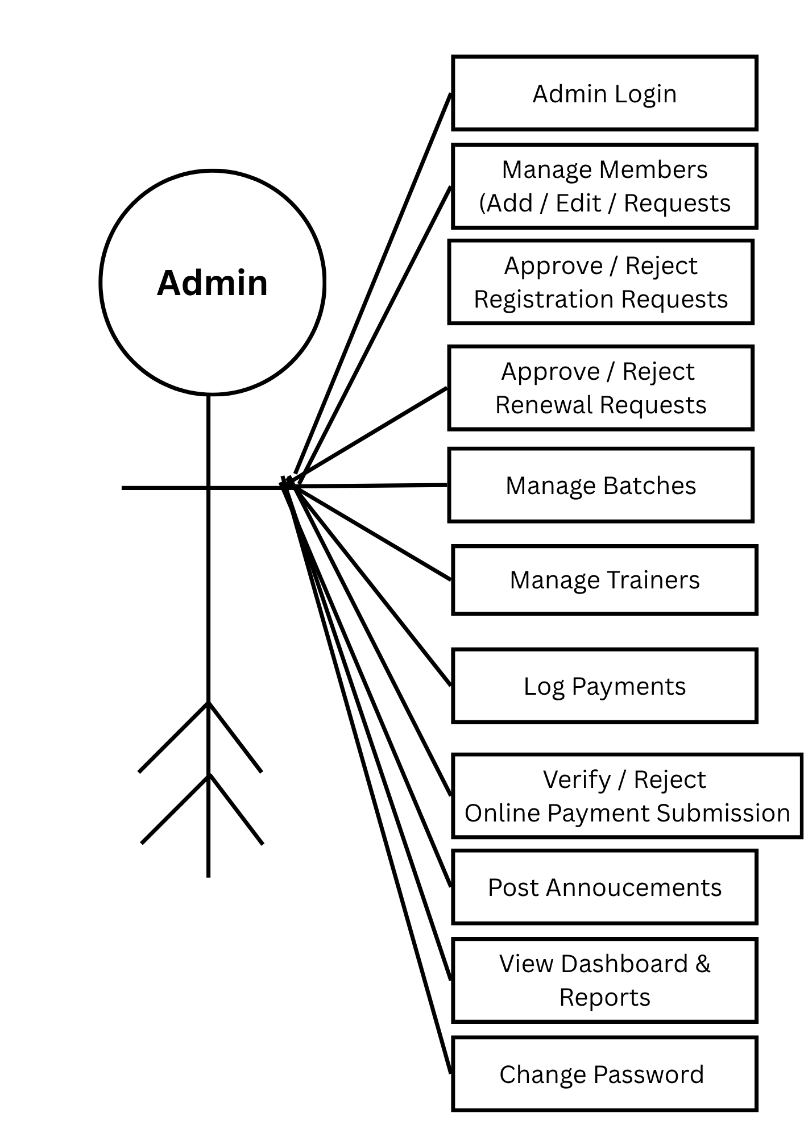
4.2 Data Flow Diagram

1. Level 0
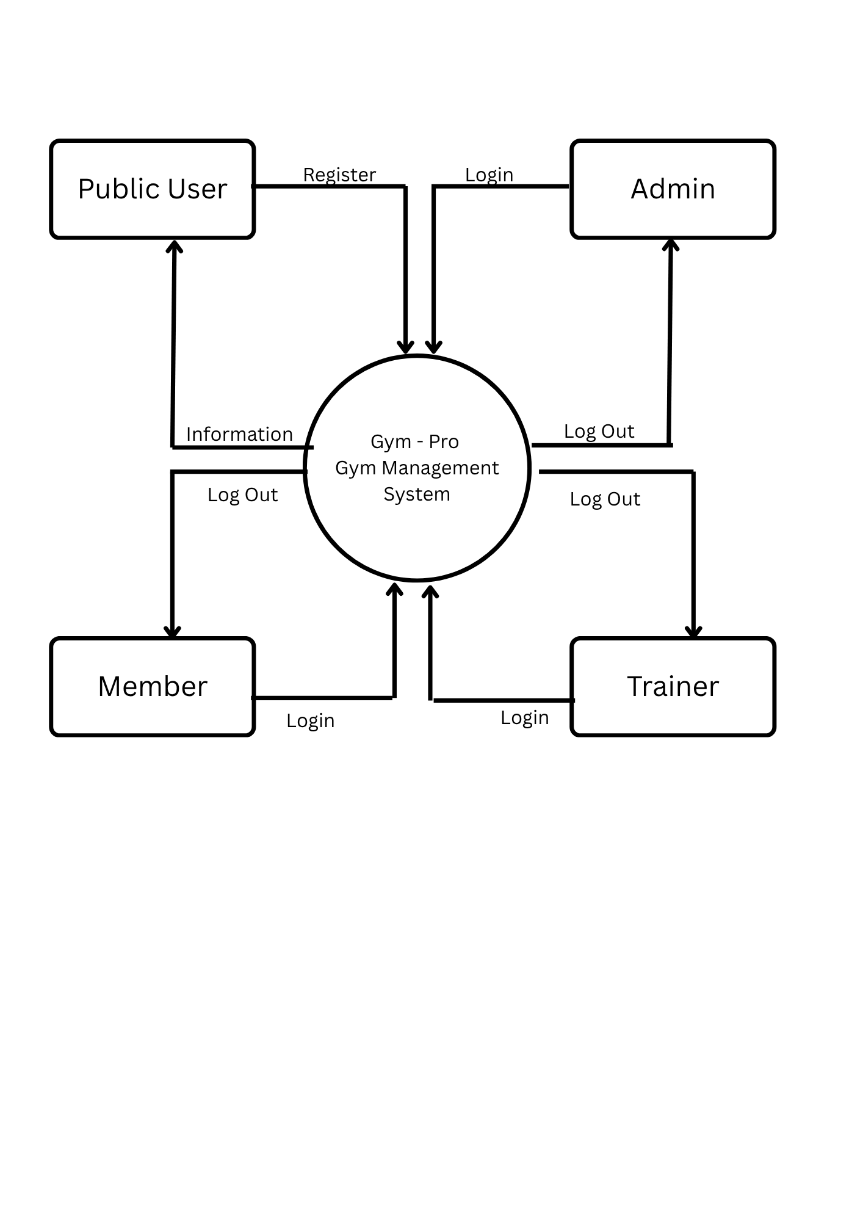

2. Level 1
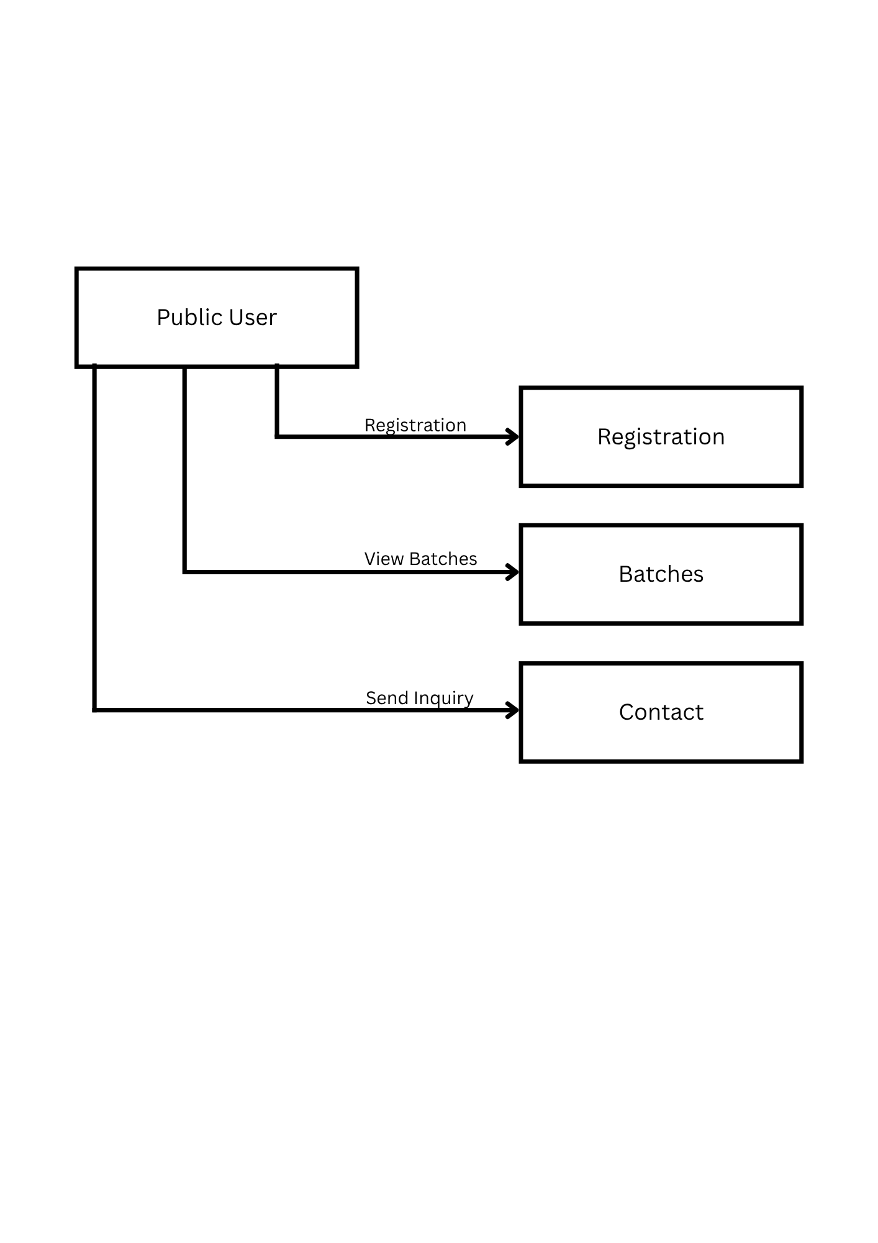
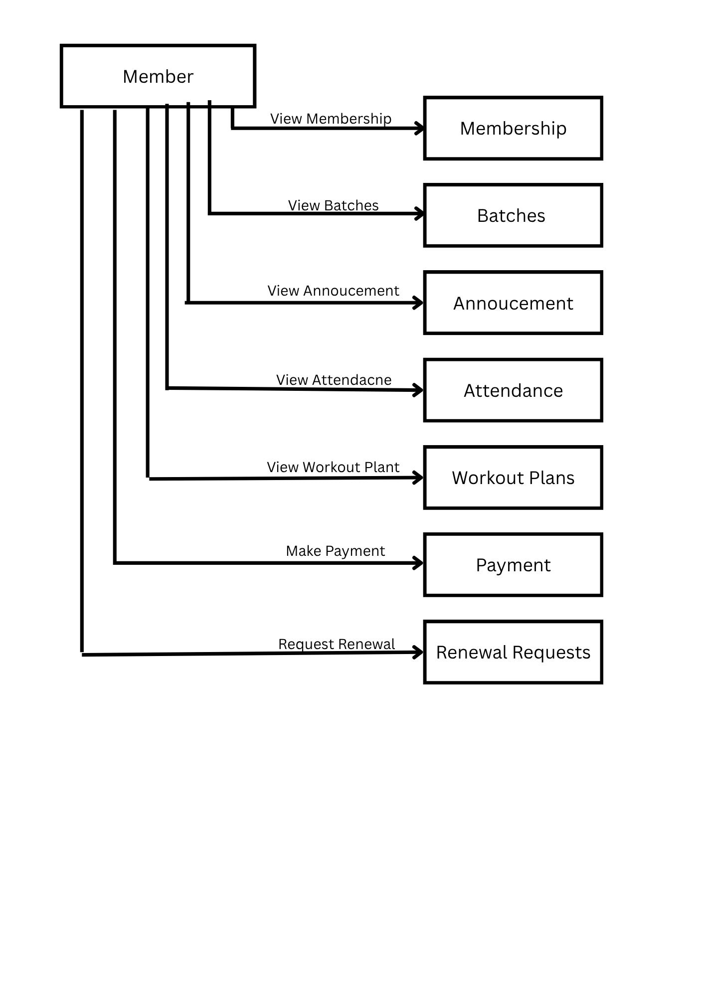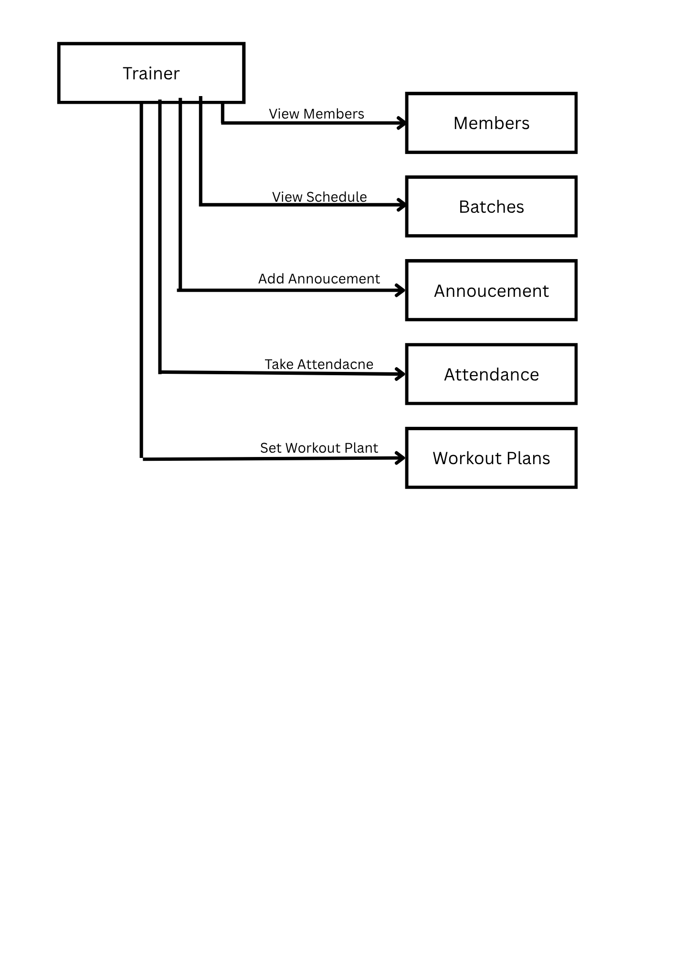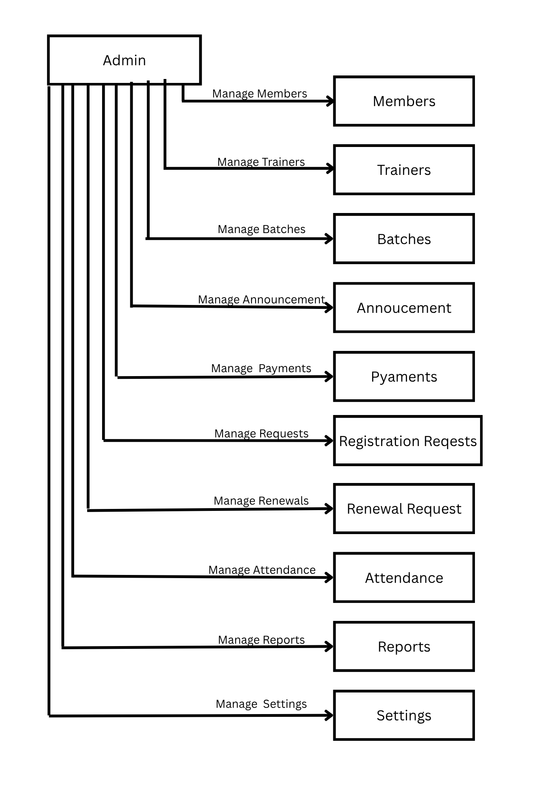
4.3 E-R Diagram
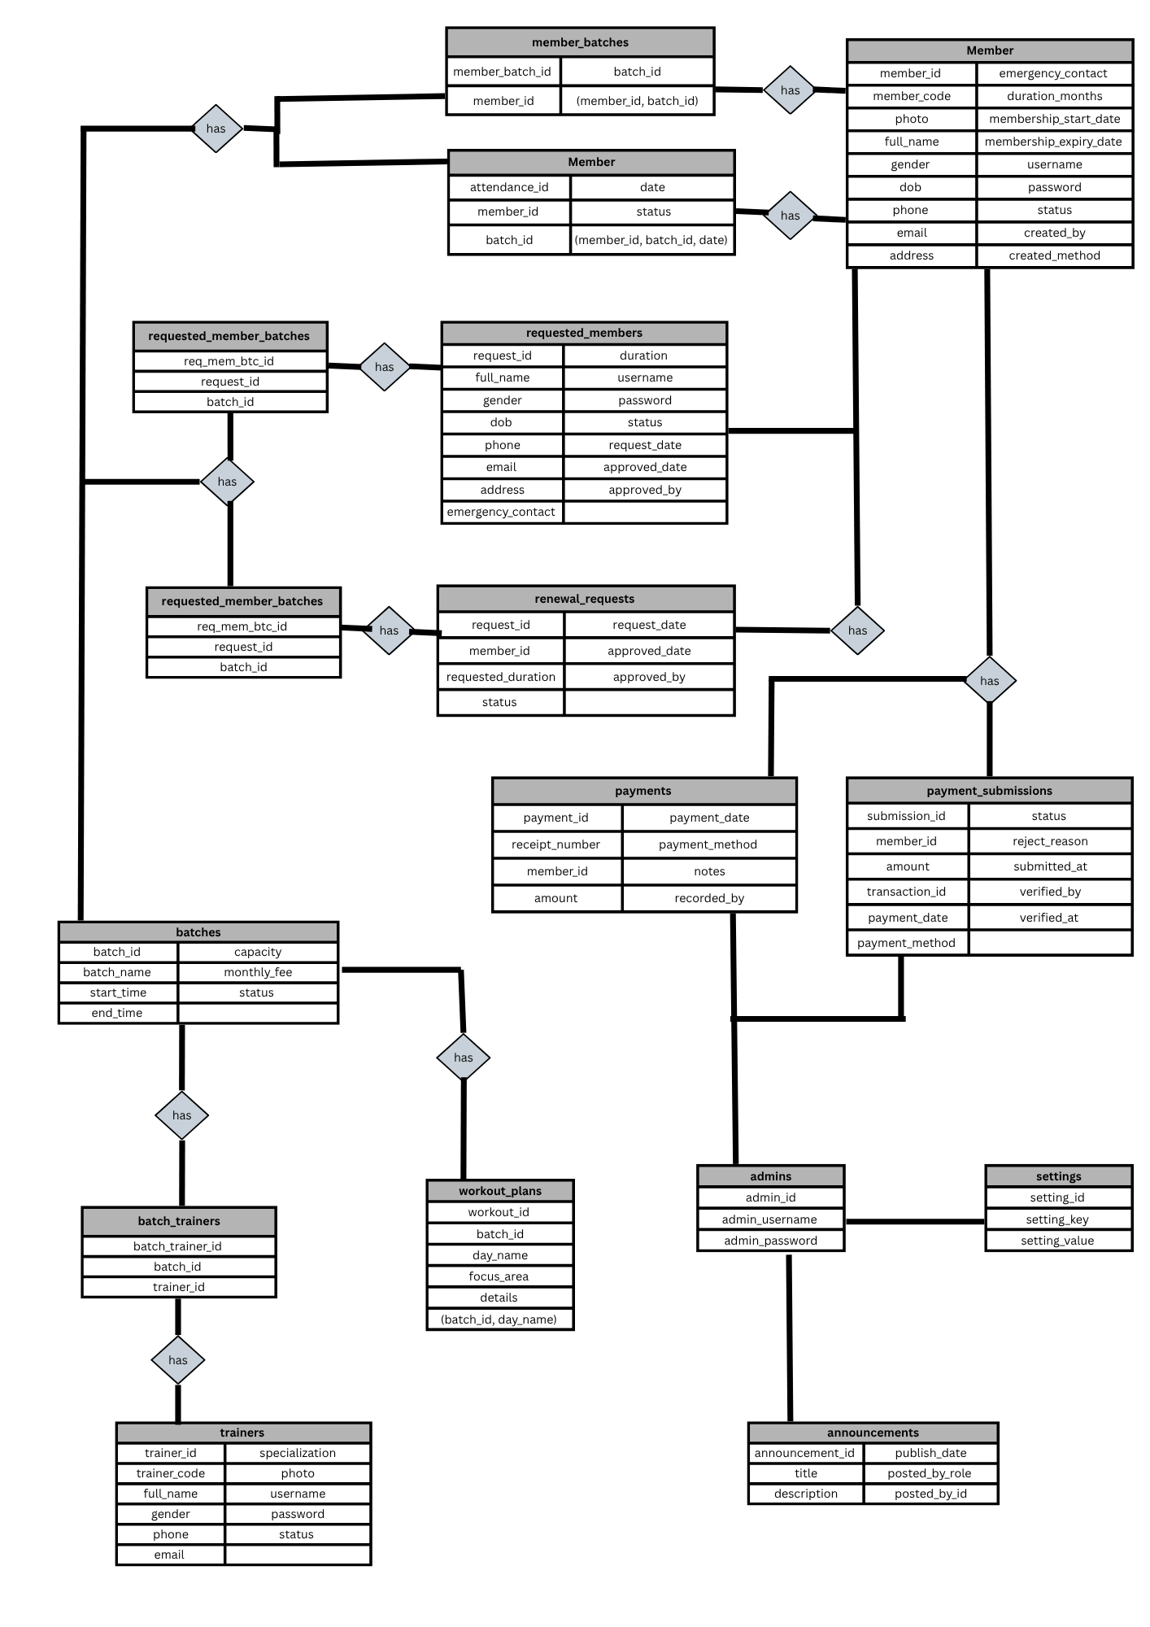

4.4 Data Dictionary
The data dictionary below lists every table of the gym_pro database exactly as created in the system (16 tables in total), showing each column, its data type and its key/constraint.
admins
Column Name | Data Type | Key / Constraint
admin_id | INT (Auto Increment) | Primary Key
admin_username | VARCHAR(50) | Not Null, Unique
admin_password | VARCHAR(255) | Not Null (hashed)

trainers
Column Name | Data Type | Key / Constraint
trainer_id | INT (Auto Increment) | Primary Key
trainer_code | VARCHAR(20) | Not Null, Unique
full_name | VARCHAR(100) | Not Null
gender | ENUM('Male','Female','Other') | Default 'Male'
phone | VARCHAR(20) | Not Null, Unique
email | VARCHAR(100) | Not Null, Unique
specialization | VARCHAR(100) | -
photo | VARCHAR(255) | Default 'default-trainer.png'
username / password | VARCHAR(50) / VARCHAR(255) | Not Null, Unique / Not Null
status | ENUM('Active','Inactive') | Default 'Active'

batches
Column Name | Data Type | Key / Constraint
batch_id | INT (Auto Increment) | Primary Key
batch_name | VARCHAR(100) | Not Null
start_time / end_time | TIME | Not Null
capacity | INT | Default 20
monthly_fee | DECIMAL(10,2) | Default 0
status | ENUM('Active','Inactive') | Default 'Active'

batch_trainers
Column Name | Data Type | Key / Constraint
batch_trainer_id | INT (Auto Increment) | Primary Key
batch_id | INT | Foreign Key -> batches
trainer_id | INT | Foreign Key -> trainers
(batch_id, trainer_id) | - | Unique Key

members
Column Name | Data Type | Key / Constraint
member_id | INT (Auto Increment) | Primary Key
member_code | VARCHAR(20) | Not Null, Unique
photo | VARCHAR(255) | Default 'default-member.png'
full_name | VARCHAR(100) | Not Null
gender | ENUM('Male','Female','Other') | Default 'Male'
dob | DATE | Not Null (18+ enforced)
phone / email | VARCHAR(20) / VARCHAR(100) | Not Null, Unique (both)
address | VARCHAR(255) | -
emergency_contact | VARCHAR(20) | -
duration_months | INT | Default 1
membership_start_date | DATE | Not Null
membership_expiry_date | DATE | Not Null
username / password | VARCHAR(50) / VARCHAR(255) | Not Null, Unique / Not Null
status | ENUM('Active','Expired','Inactive','Pending Payment') | Default 'Active'
created_by | VARCHAR(50) | -
created_method | ENUM('Request','Admin') | Default 'Admin'

member_batches
Column Name | Data Type | Key / Constraint
member_batch_id | INT (Auto Increment) | Primary Key
member_id | INT | Foreign Key -> members
batch_id | INT | Foreign Key -> batches
(member_id, batch_id) | - | Unique Key

payments
Column Name | Data Type | Key / Constraint
payment_id | INT (Auto Increment) | Primary Key
receipt_number | VARCHAR(20) | Not Null, Unique
member_id | INT | Foreign Key -> members
amount | DECIMAL(10,2) | Not Null
payment_date | DATE | Not Null
payment_method | ENUM('Cash','UPI','Card','Bank Transfer','Other') | Default 'Cash'
notes | VARCHAR(255) | -
recorded_by | INT | Foreign Key -> admins

payment_submissions
Column Name | Data Type | Key / Constraint
submission_id | INT (Auto Increment) | Primary Key
member_id | INT | Foreign Key -> members
amount | DECIMAL(10,2) | Not Null (system-calculated)
transaction_id | VARCHAR(100) | Not Null
payment_date | DATE | Not Null
payment_method | VARCHAR(20) | Default 'UPI'
status | ENUM('Pending Verification','Verified','Rejected') | Default 'Pending Verification'
reject_reason | VARCHAR(255) | -
submitted_at | DATETIME | Default Current Timestamp
verified_by | INT | Foreign Key -> admins (nullable)
verified_at | DATETIME | -

requested_members
Column Name | Data Type | Key / Constraint
request_id | INT (Auto Increment) | Primary Key
full_name, gender, dob | VARCHAR/ENUM/DATE | full_name Not Null
phone, email | VARCHAR(20) / VARCHAR(100) | Not Null
address, emergency_contact | VARCHAR | -
duration | INT | Default 1
username / password | VARCHAR(50) / VARCHAR(255) | Not Null
status | ENUM('Pending','Approved','Rejected') | Default 'Pending'
request_date / approved_date | DATETIME | Default Current / Null
approved_by | INT | Foreign Key -> admins (nullable)

requested_member_batches
Column Name | Data Type | Key / Constraint
req_mem_btc_id | INT (Auto Increment) | Primary Key
request_id | INT | Foreign Key -> requested_members
batch_id | INT | Foreign Key -> batches

renewal_requests
Column Name | Data Type | Key / Constraint
renewal_id | INT (Auto Increment) | Primary Key
member_id | INT | Foreign Key -> members
requested_duration | INT | Default 1
status | ENUM('Pending','Approved','Rejected') | Default 'Pending'
request_date / approved_date | DATETIME | Default Current / Null
approved_by | INT | Foreign Key -> admins (nullable)

renewal_request_batches
Column Name | Data Type | Key / Constraint
renwl_req_btc_id | INT (Auto Increment) | Primary Key
renewal_id | INT | Foreign Key -> renewal_requests
batch_id | INT | Foreign Key -> batches

announcements
Column Name | Data Type | Key / Constraint
announcement_id | INT (Auto Increment) | Primary Key
title | VARCHAR(150) | Not Null
description | TEXT | Not Null
publish_date | DATETIME | Default Current Timestamp
posted_by_role | ENUM('Admin','Trainer') | Default 'Admin'
posted_by_id | INT | Not Null

workout_plans
Column Name | Data Type | Key / Constraint
workout_id | INT (Auto Increment) | Primary Key
batch_id | INT | Foreign Key -> batches
day_name | ENUM('Monday'…'Sunday') | Not Null
focus_area | VARCHAR(100) | -
details | TEXT | -
(batch_id, day_name) | - | Unique Key

attendance
Column Name | Data Type | Key / Constraint
attendance_id | INT (Auto Increment) | Primary Key
member_id | INT | Foreign Key -> members
batch_id | INT | Foreign Key -> batches
date | DATE | Not Null
status | ENUM('Present','Absent') | Default 'Present'
(member_id, batch_id, date) | - | Unique Key

settings
Column Name | Data Type | Key / Constraint
setting_id | INT (Auto Increment) | Primary Key
setting_key | VARCHAR(50) | Not Null, Unique
setting_value | VARCHAR(255) | Not Null (e.g. gym_upi_id)

5. Screen Design
1. Public User Side

- Home

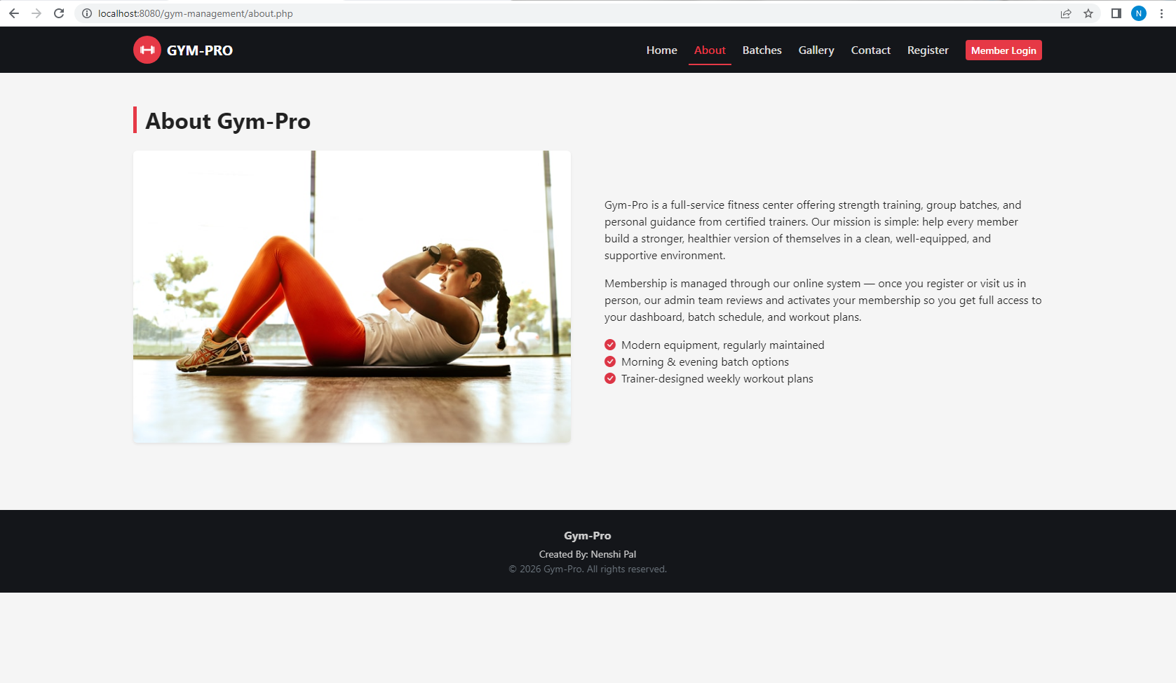
- About

- Batches
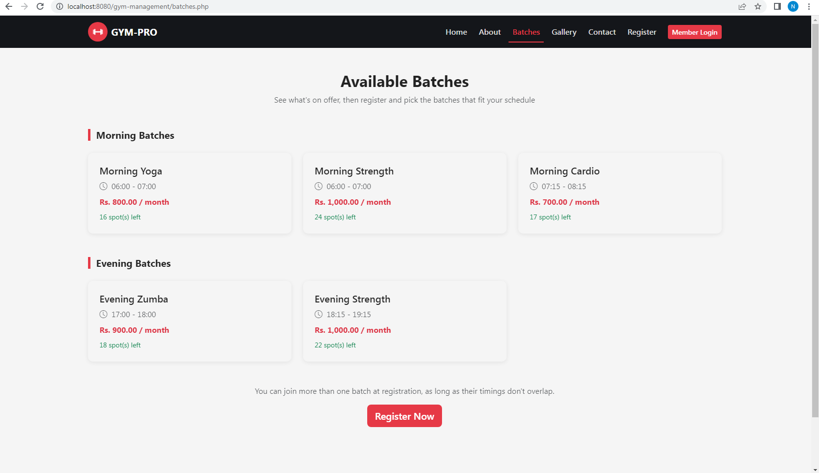


- Gallery

- Contact

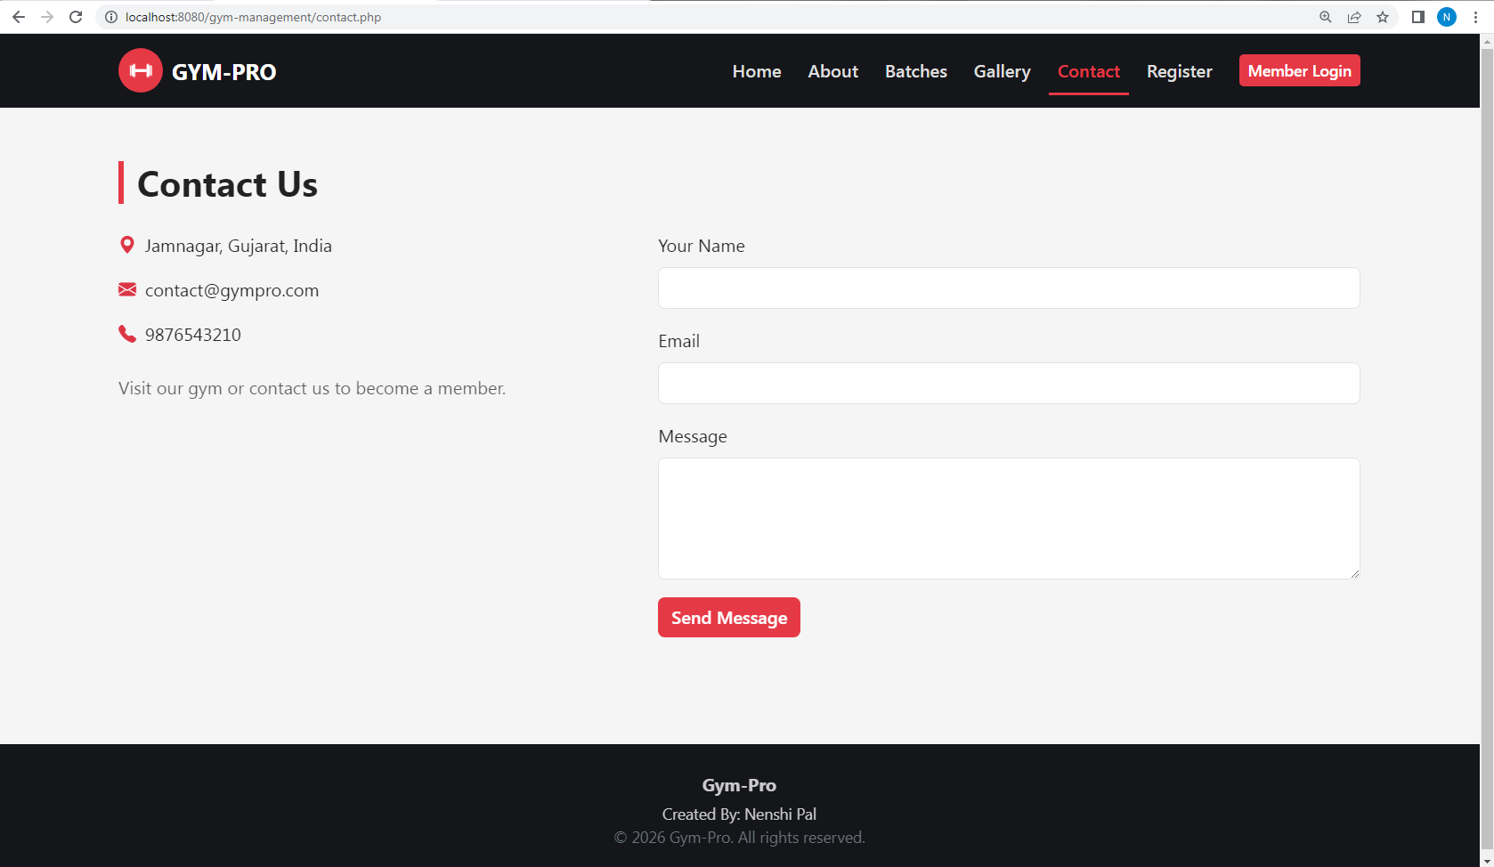

- Register

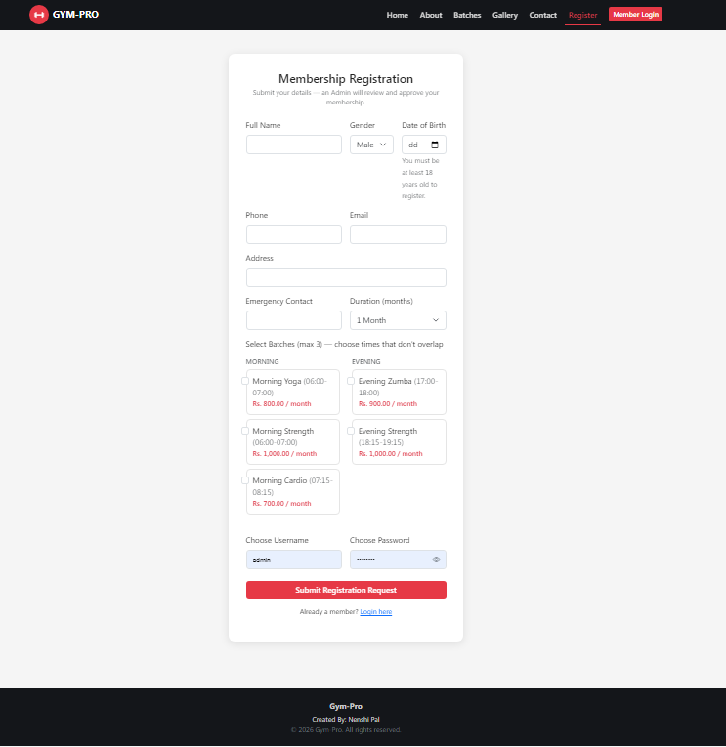

- Member Login
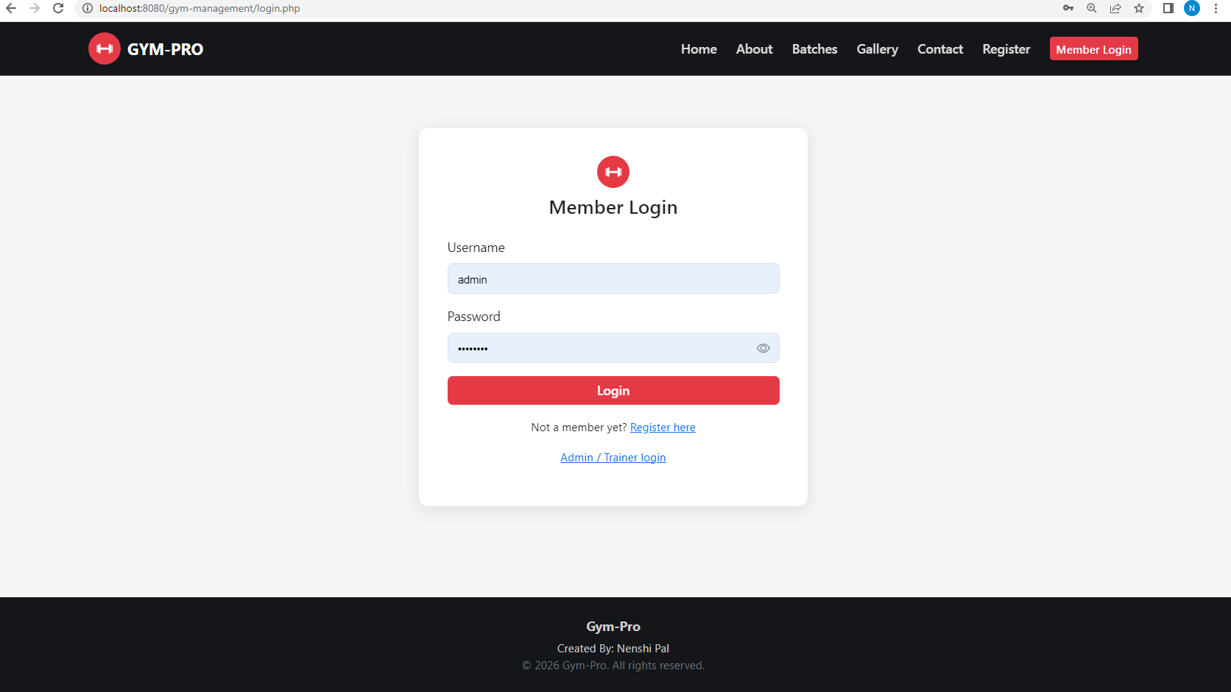

2. Admin side
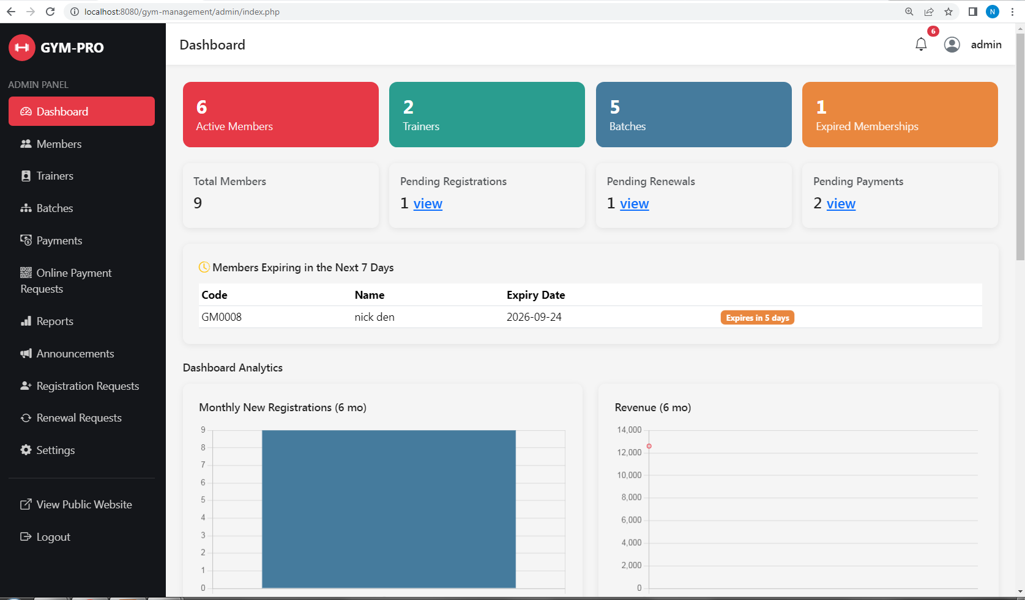
- Dashboard

- Members
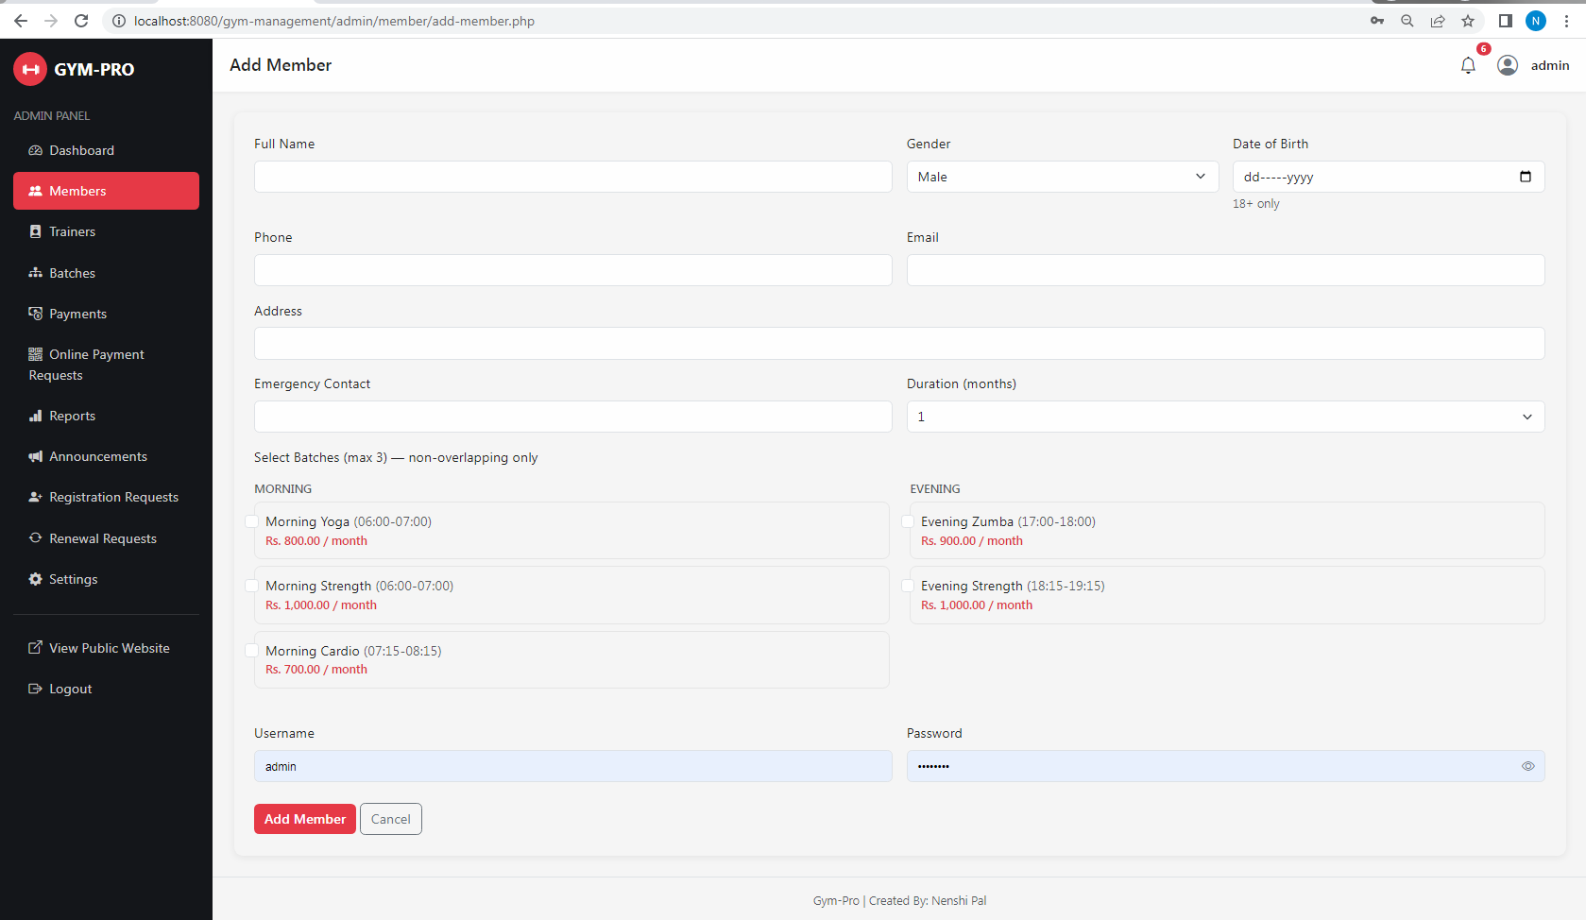

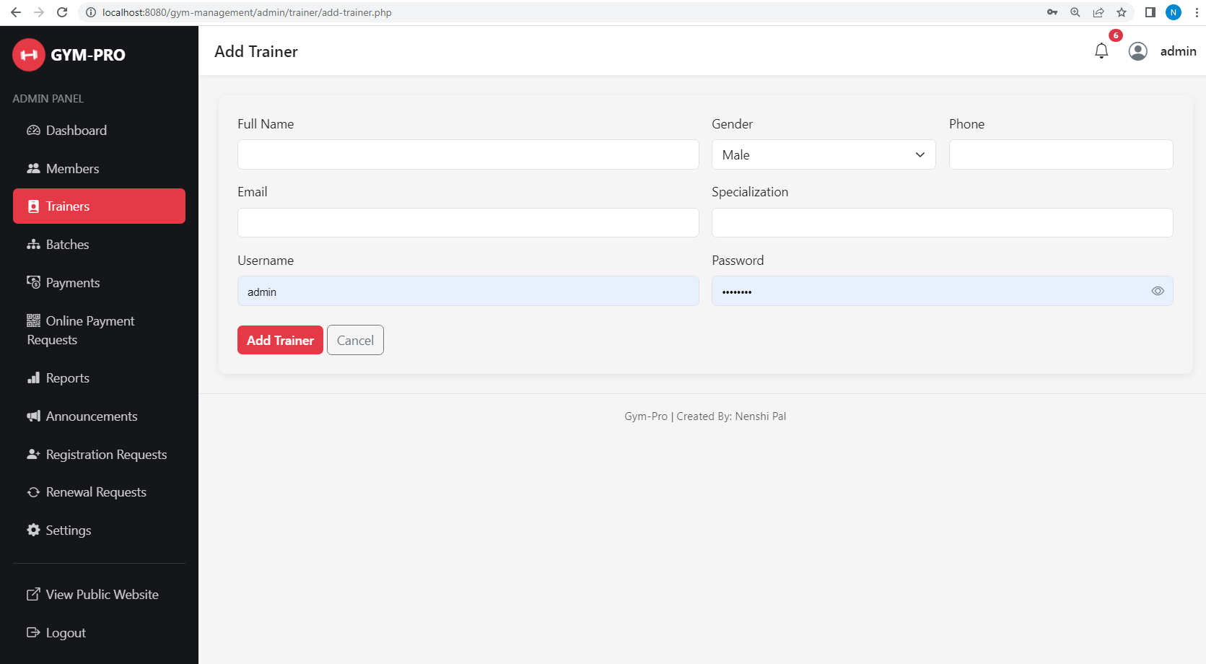
- Trainer

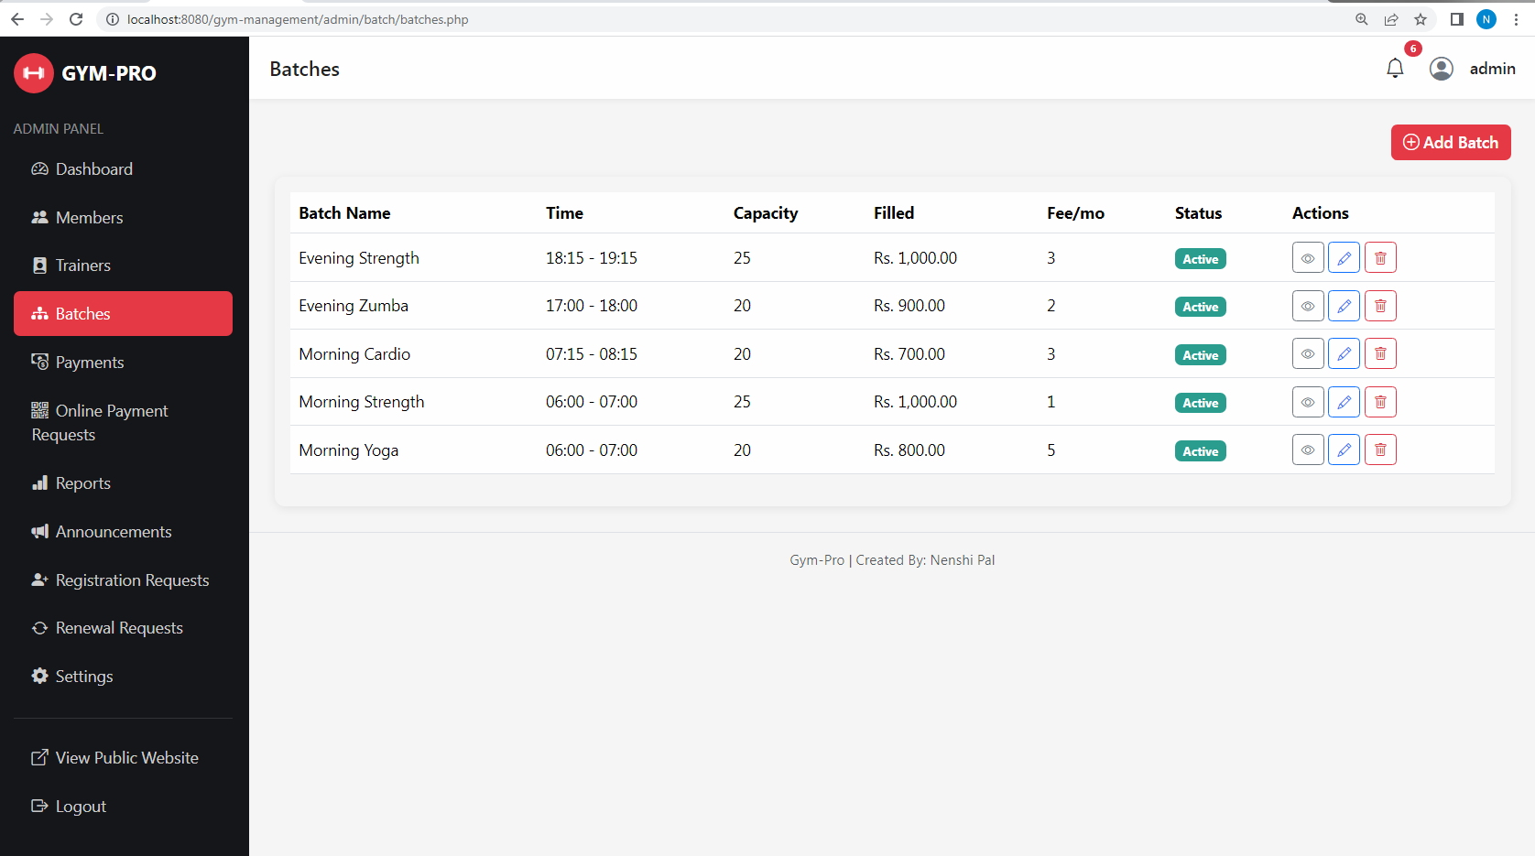
- Batches

- Payment
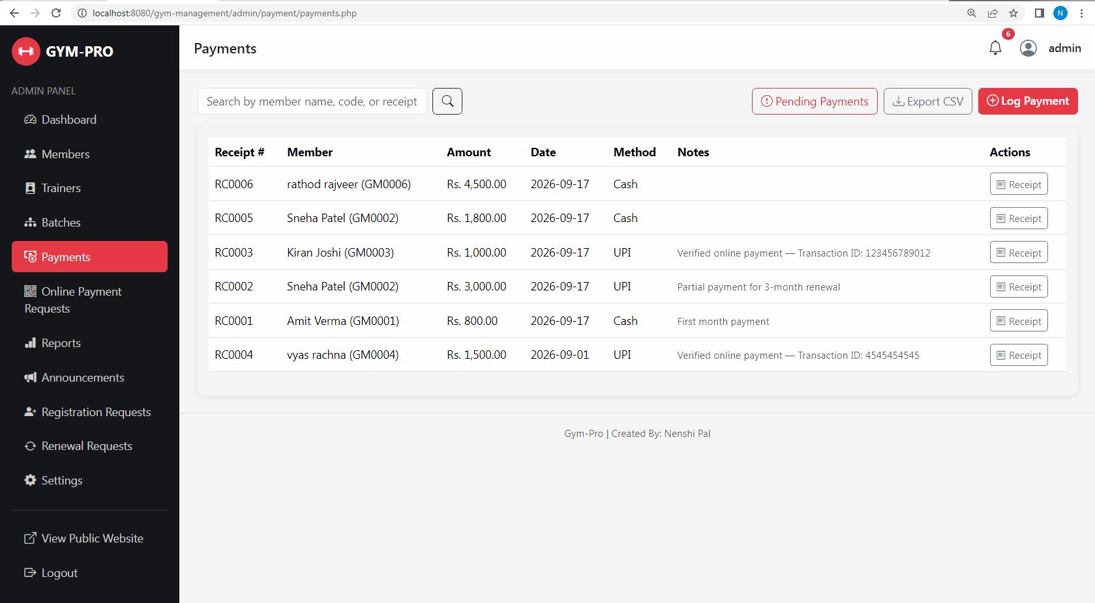

- Online Payment Request
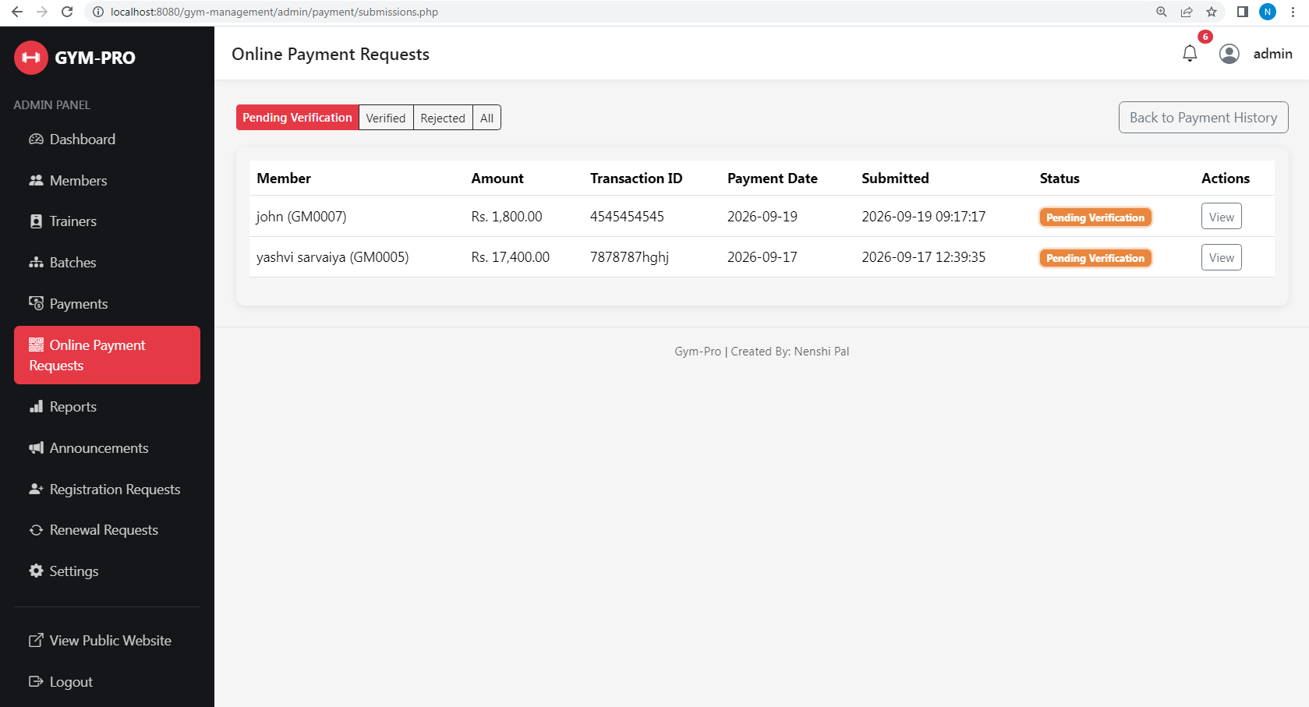

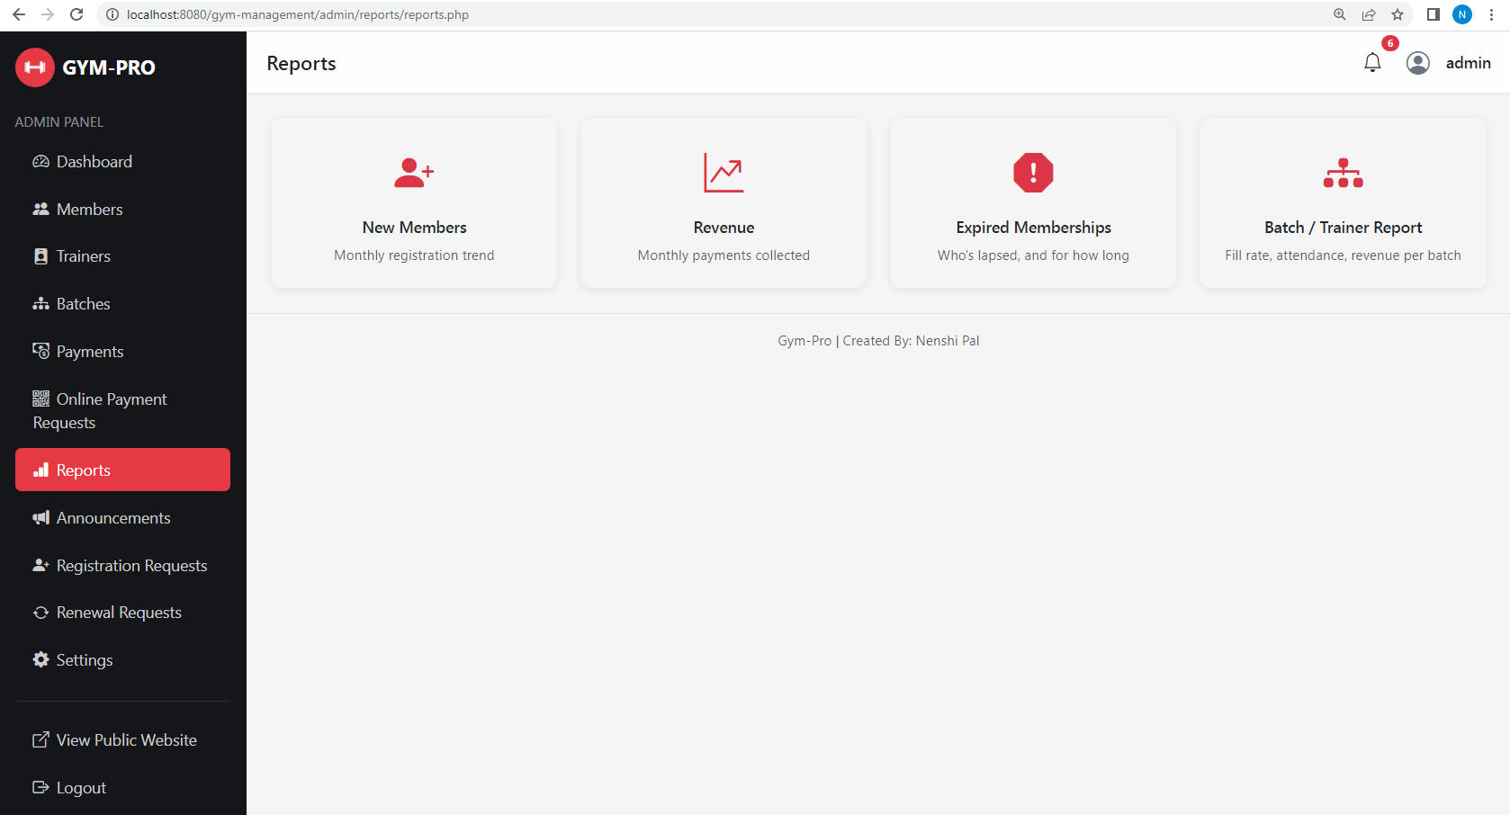
- Reports

- Announcement

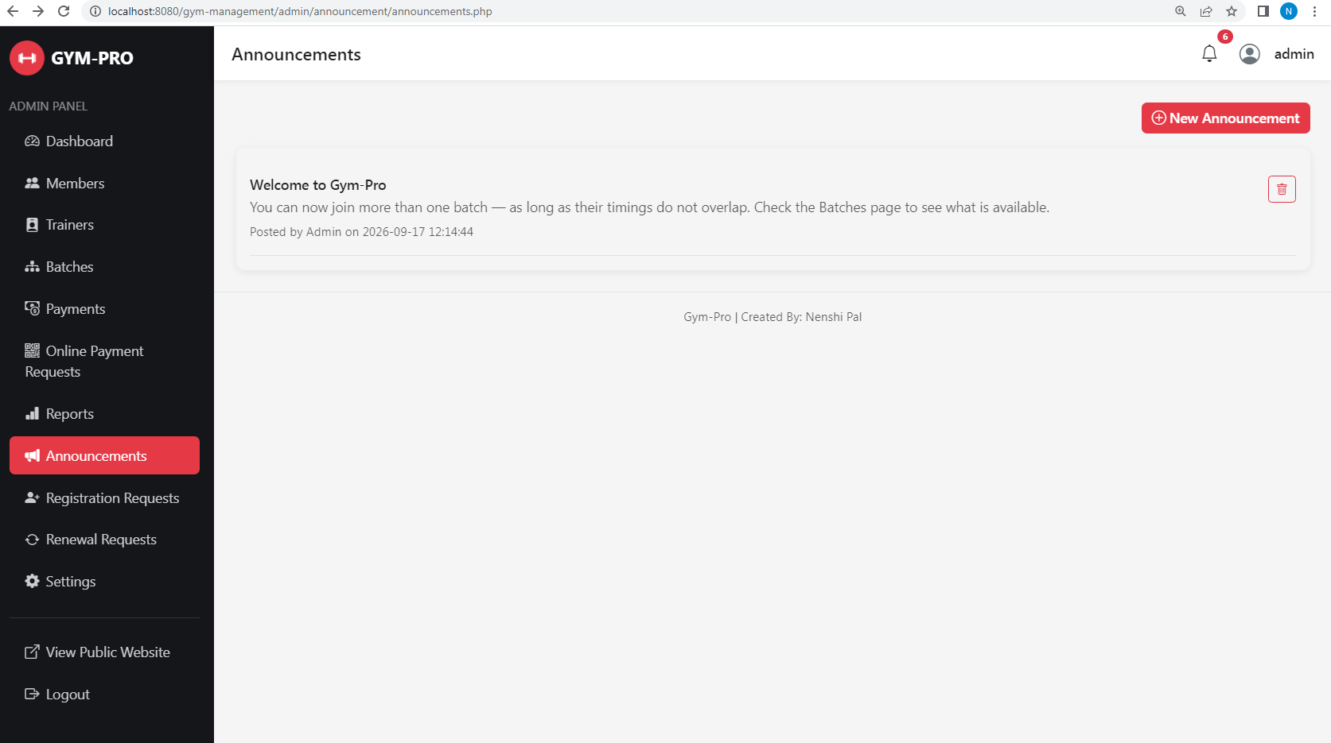

- Registration requests
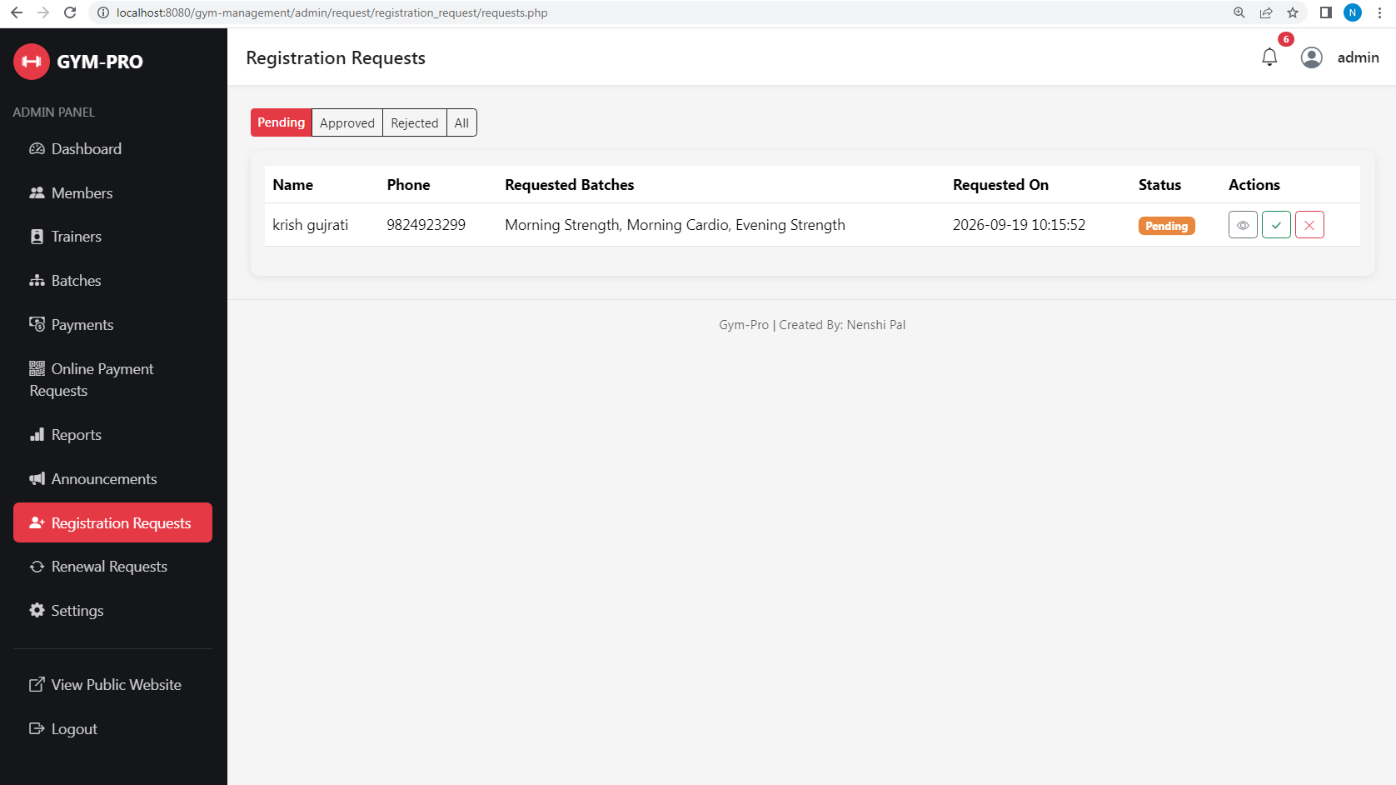

- Renewal requests
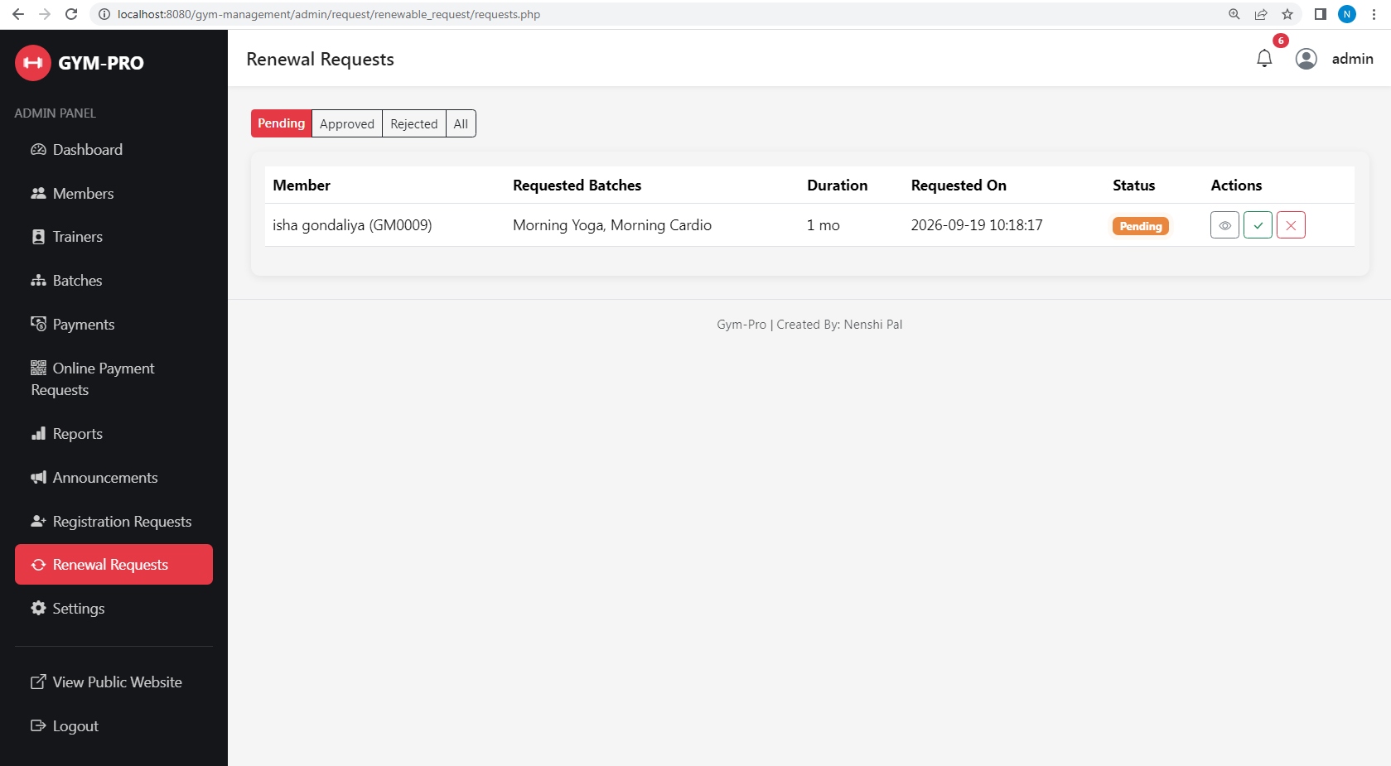

- Setting
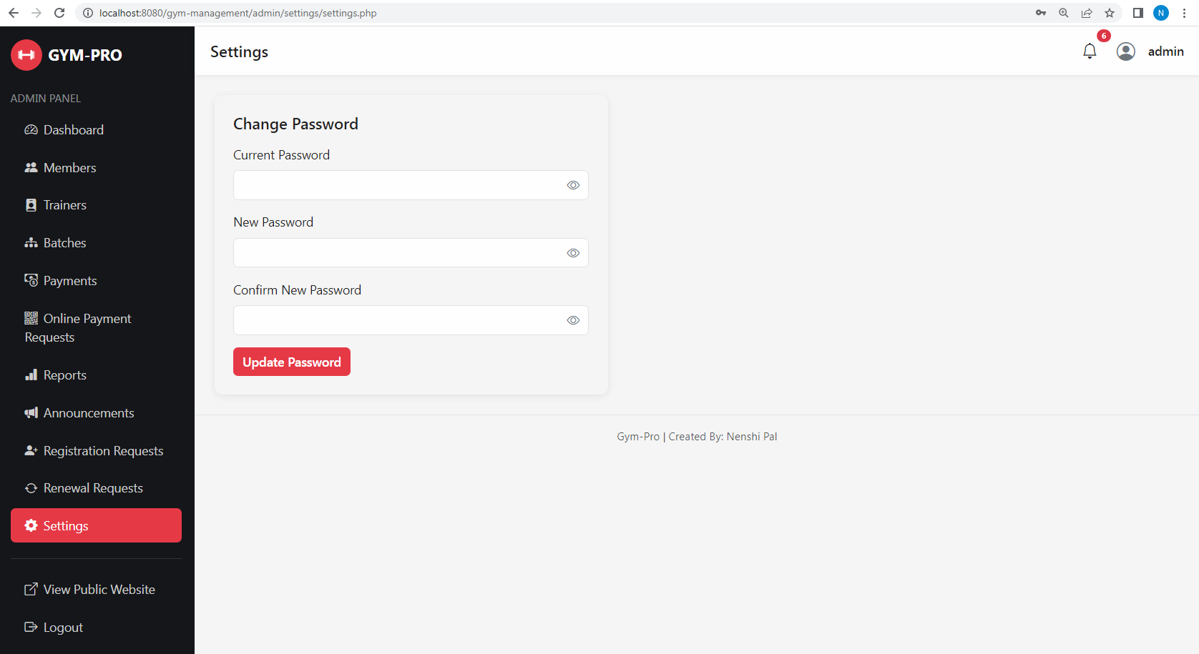

3. Trainer side
- Dashboard
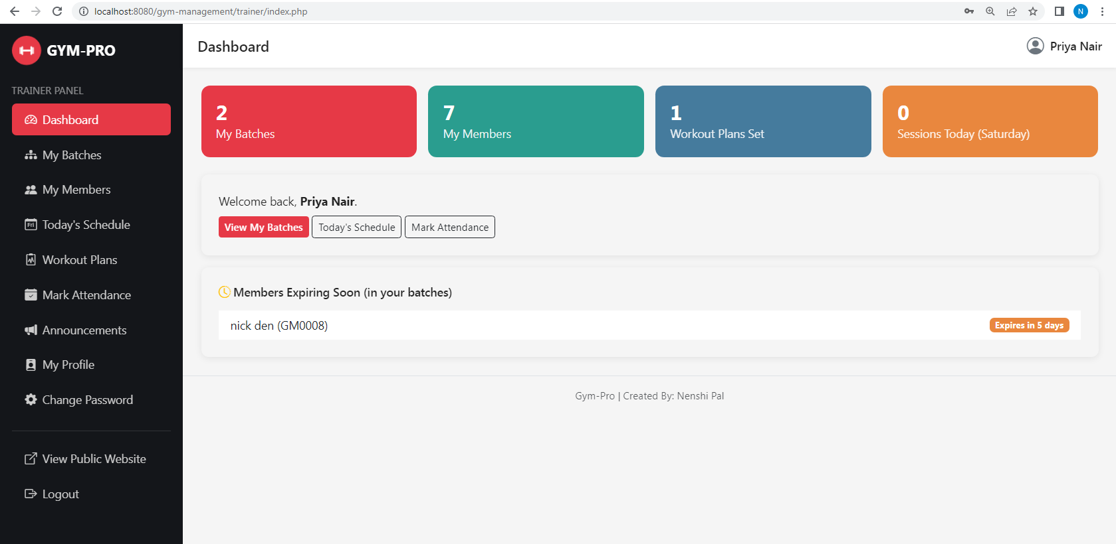

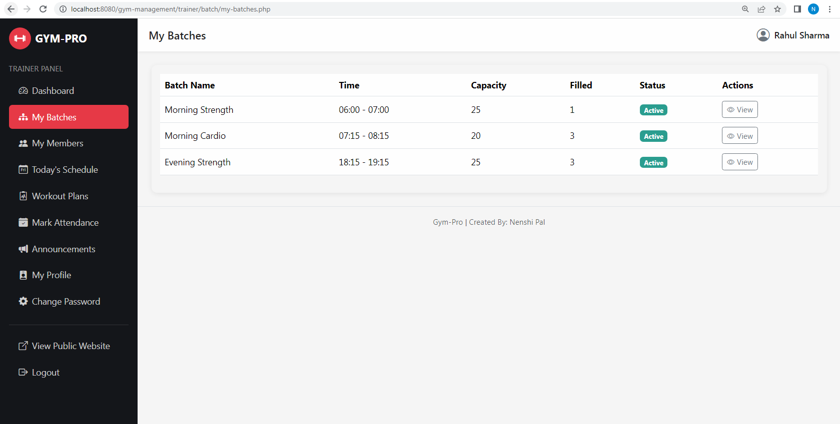
- My Batches

- My Member
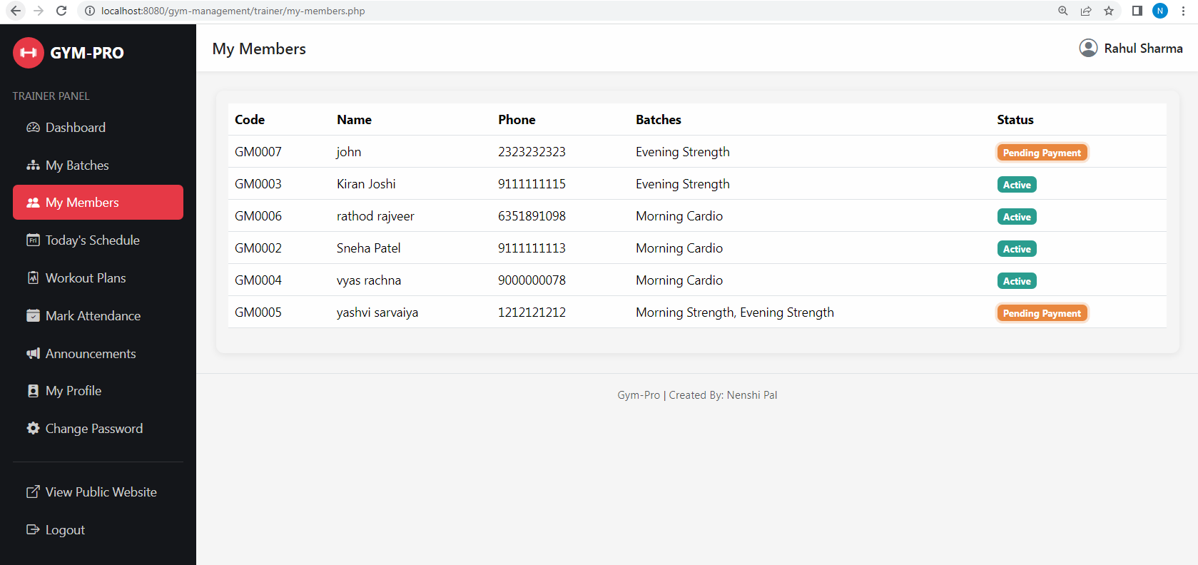

- Today’s Schedule

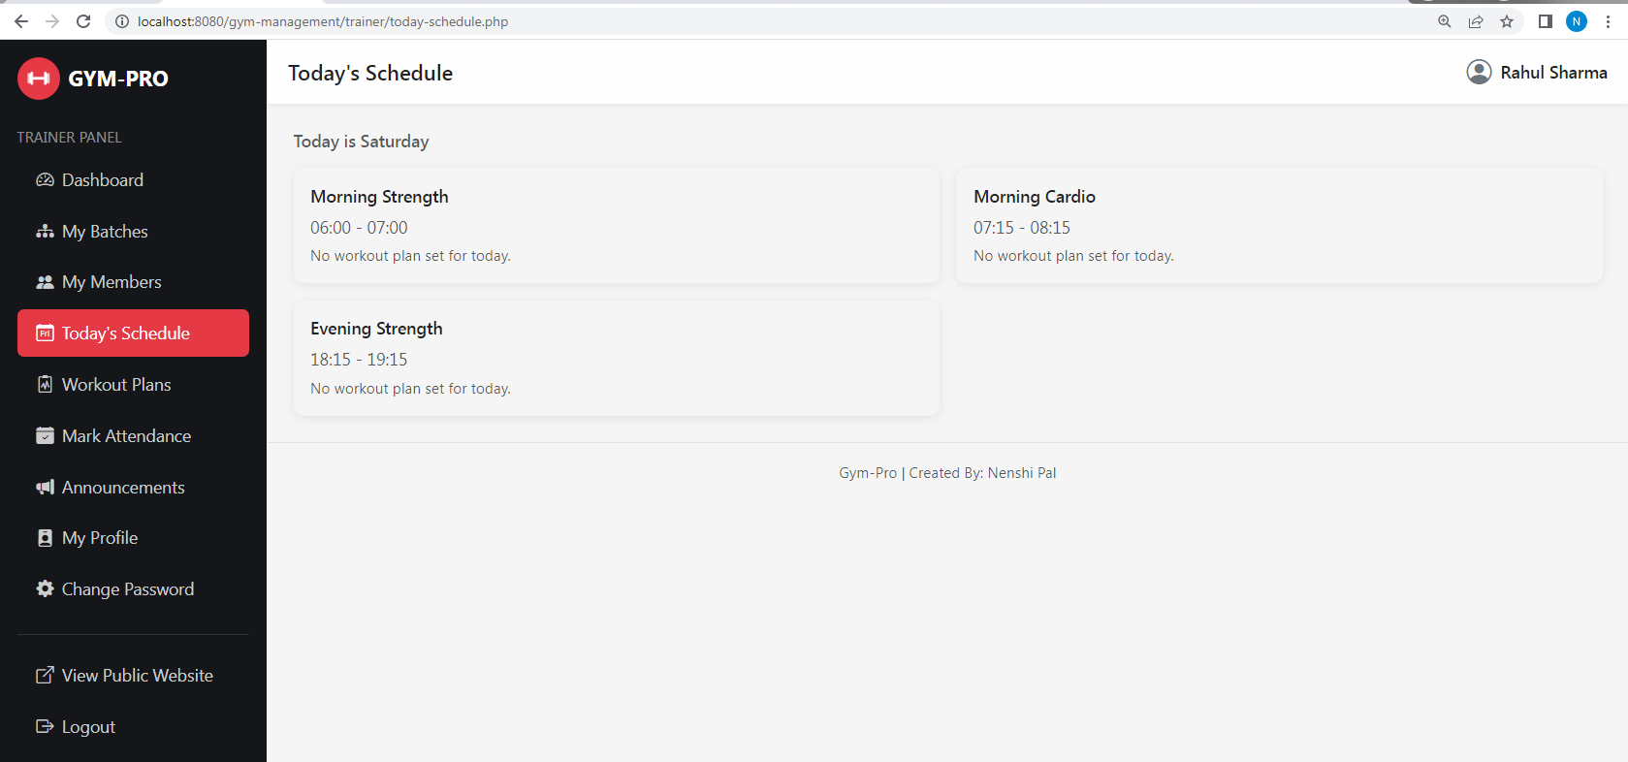

- Workout Plans
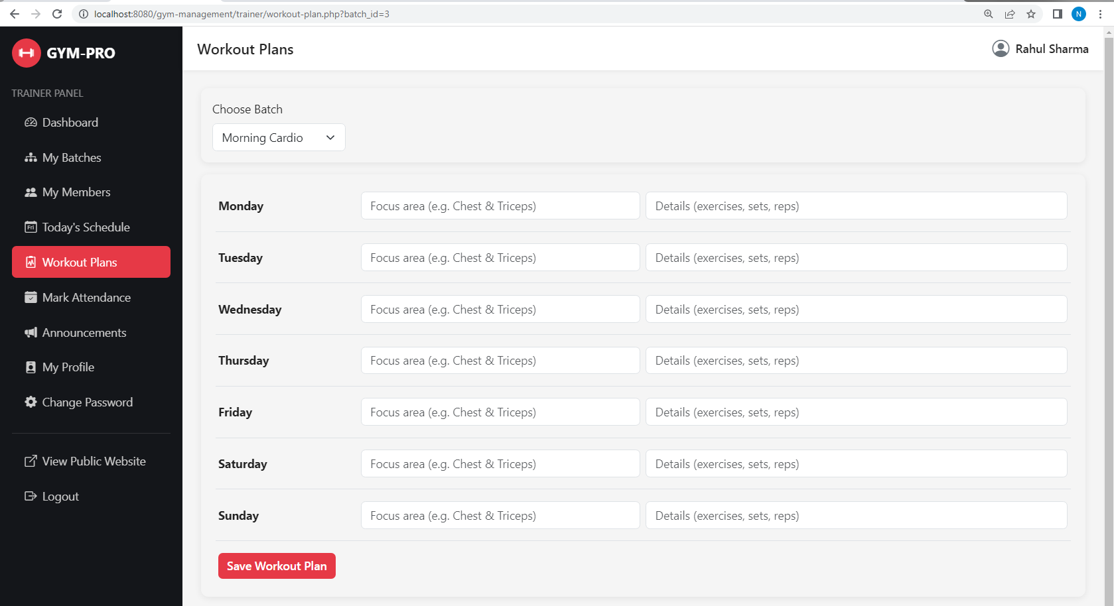

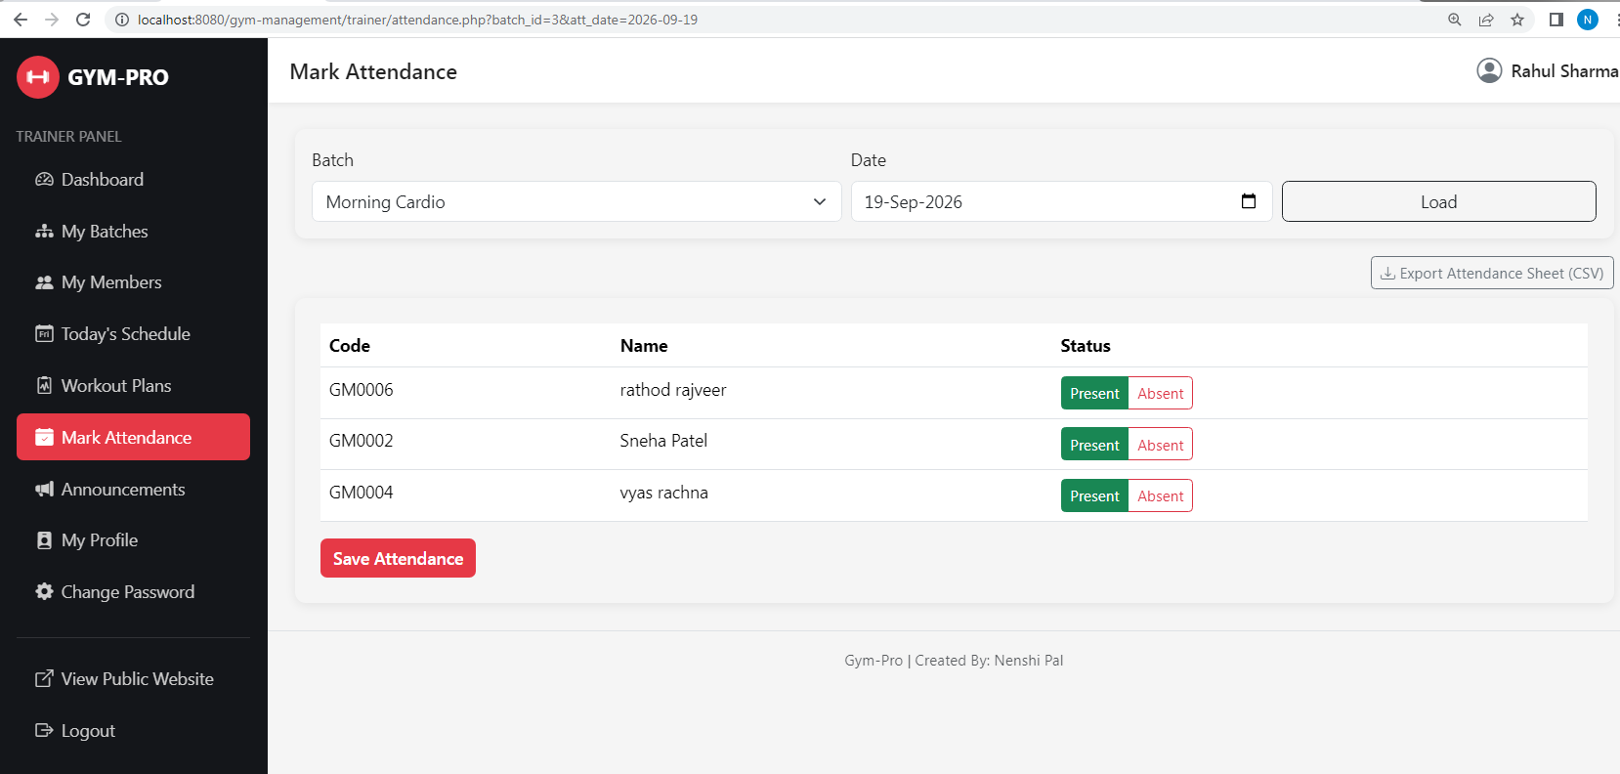
- Mark Attendance

- My Profile

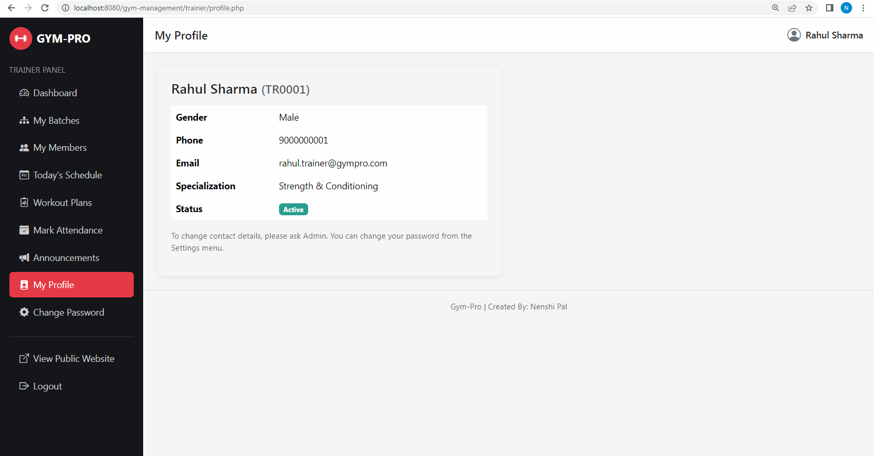

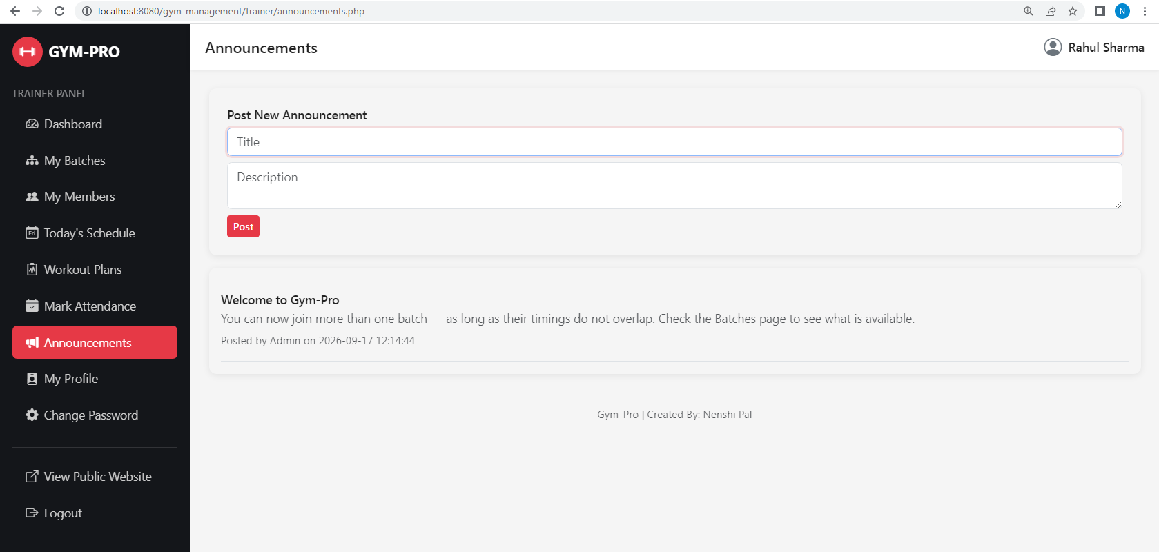
- Announcement

- Change Password

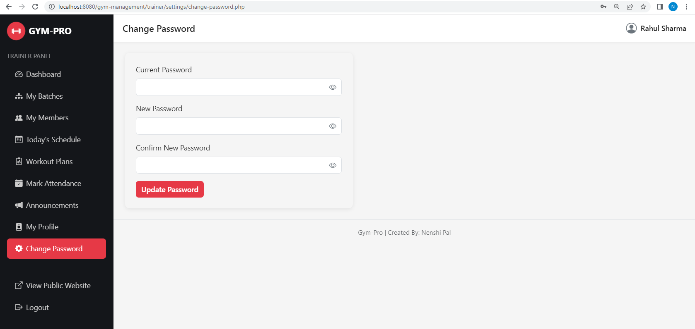

4. Member

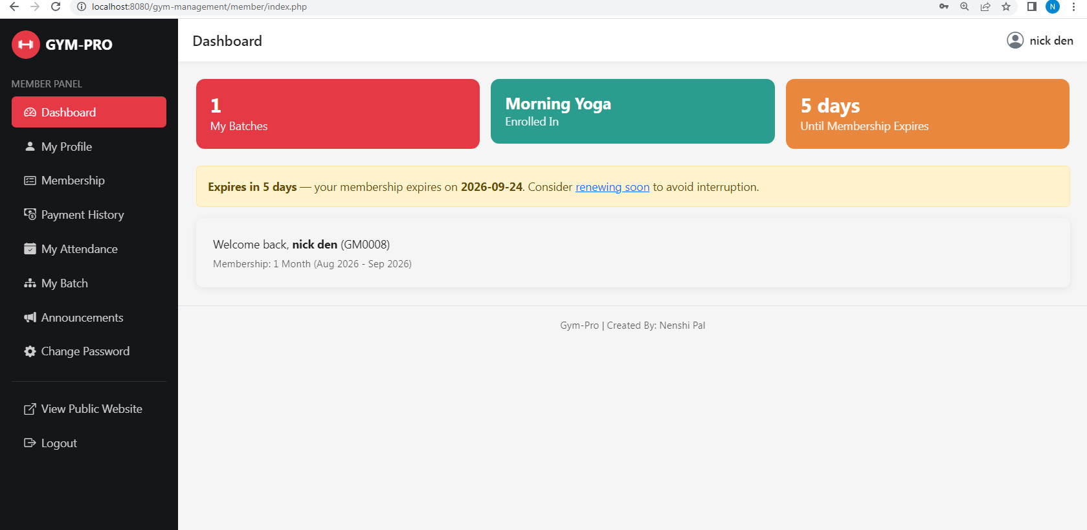
- Dashboard

- My Profile
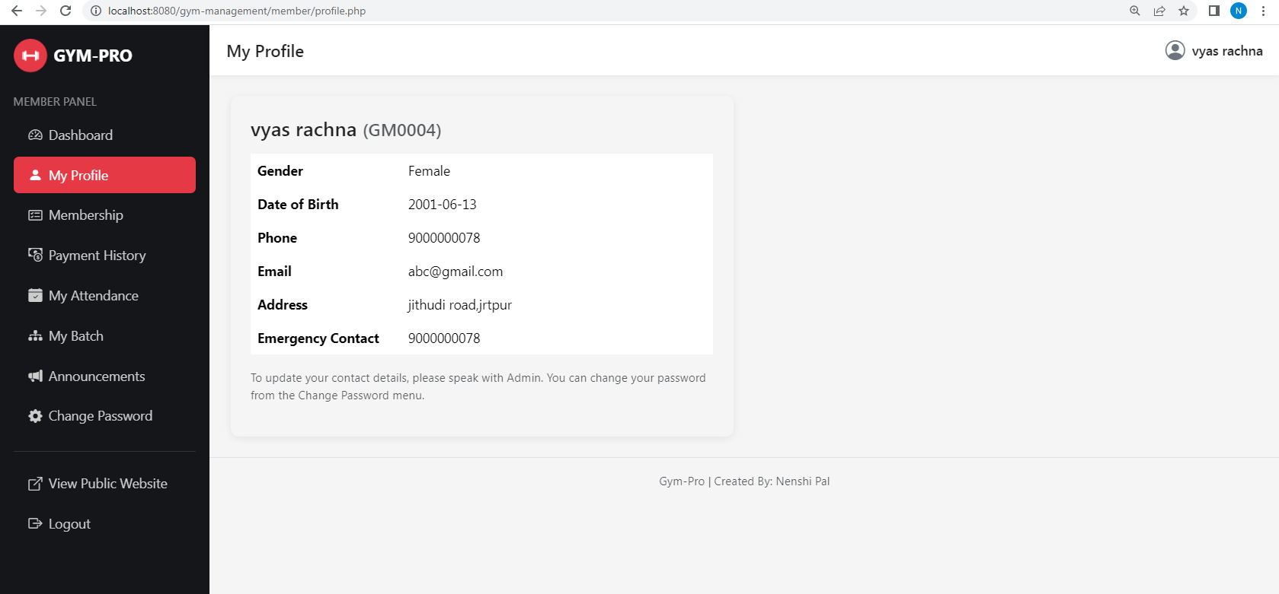

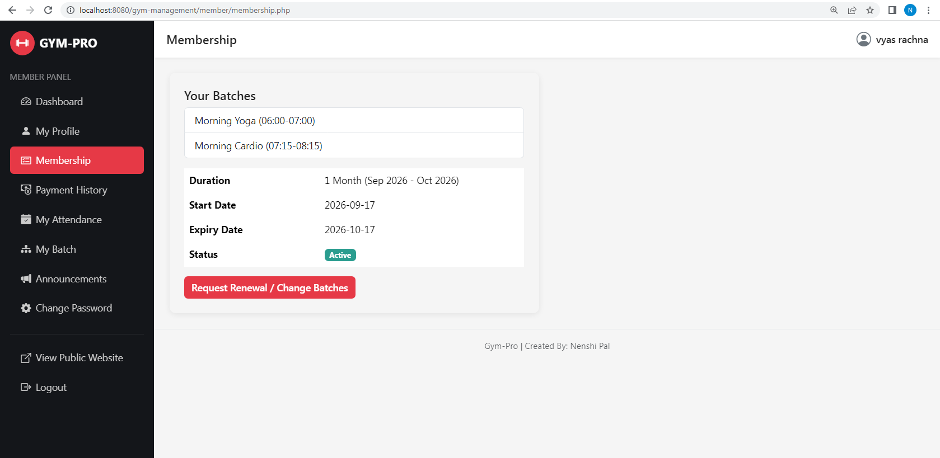
- My Membership

- Payment History
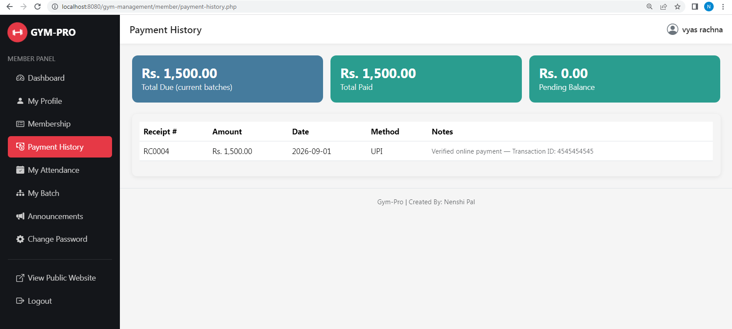

- My Attendance
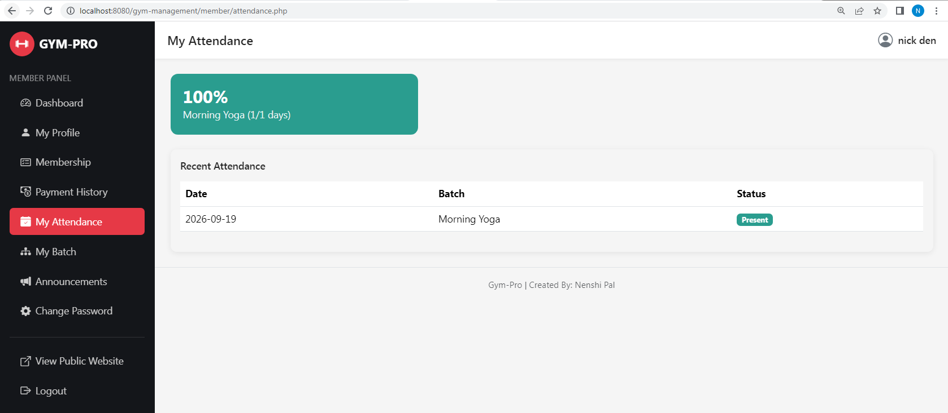

- My Batch

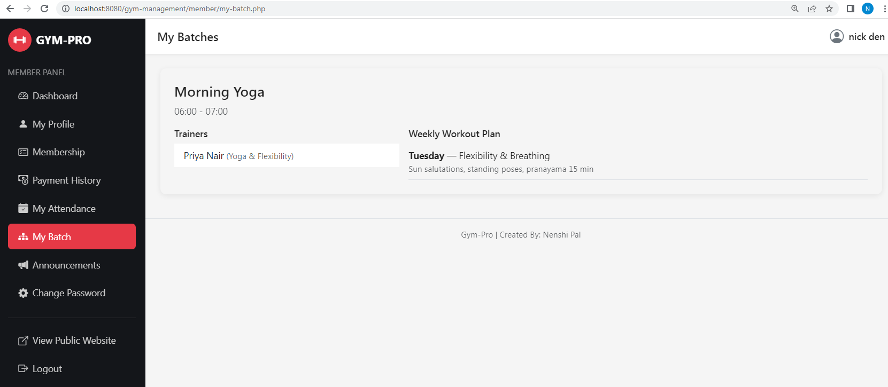

- Pending Payment

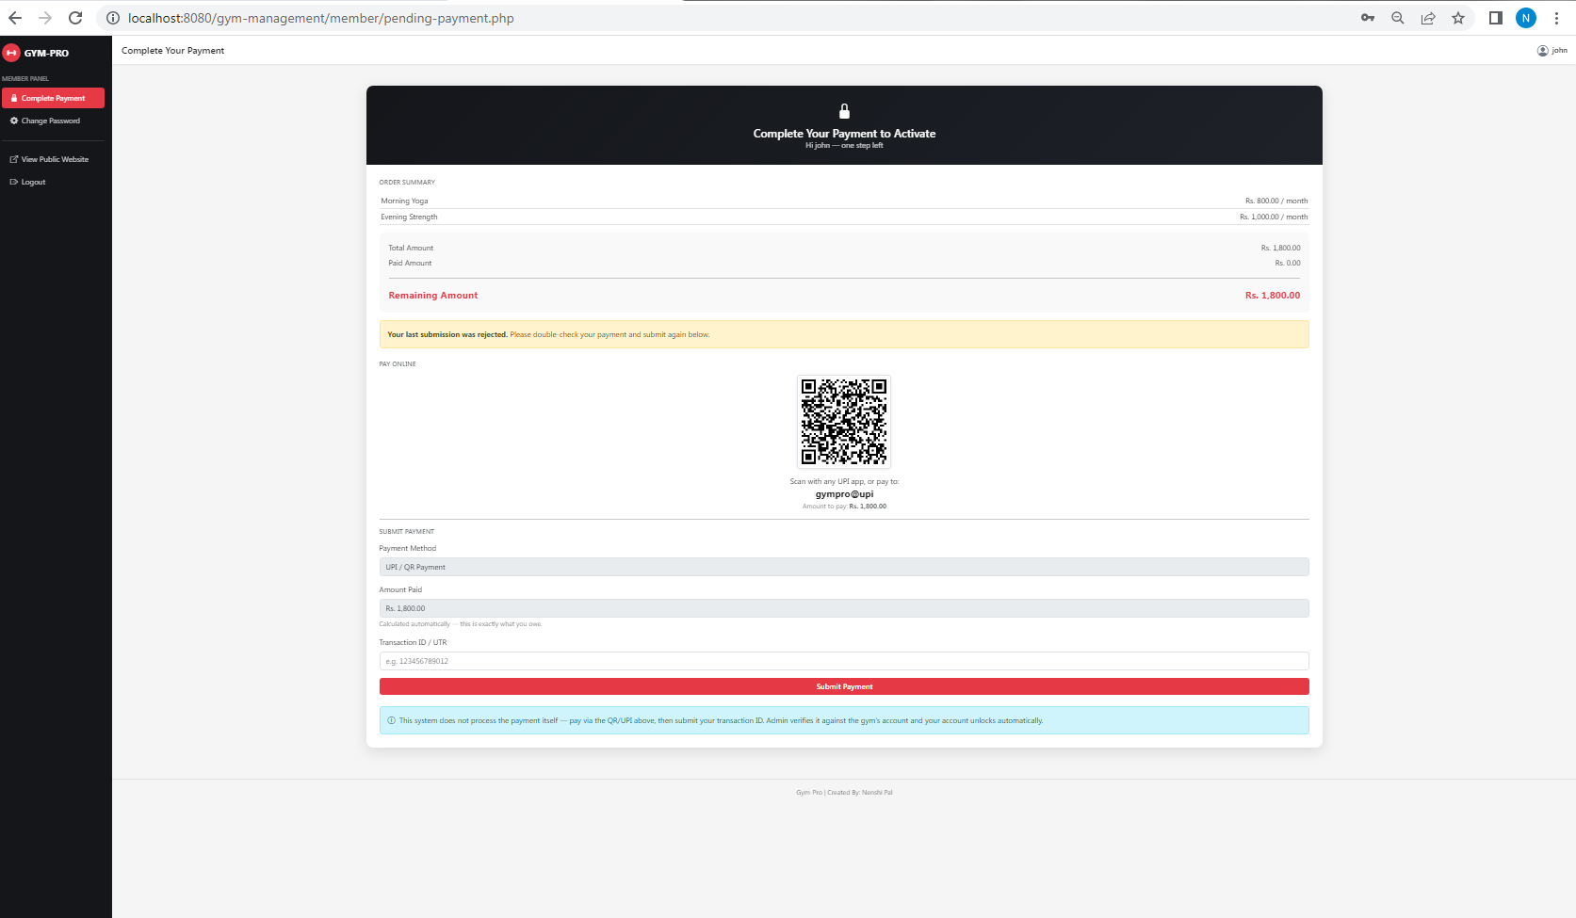

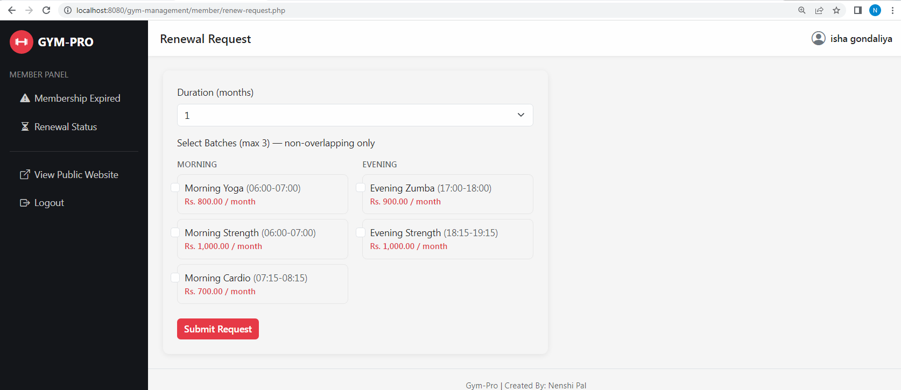
- Renewal – Request

6. Software Testing
6.1 manual testing
Black Box Testing is performed by providing inputs to the system and verifying whether the resulting behaviour matches the expected functionality. The internal implementation of the system is not considered during this testing.
For GYM PRO – Gym Management System, Black Box Testing is presented in two parts below: Input Validation Testing, which checks how each form reacts to valid, blank, invalid and boundary input; and Functional Testing, which checks that each feature performs its intended operation correctly.
Result: The tested Black Box functions and validation scenarios produced the expected results.
Black Box Testing – Input Validation Testing
Every field of every form was tested using four input types:
- Input Type 1: Valid input
- Input Type 2: Mandatory field left blank
- Input Type 3: Invalid input
- Input Type 4: Optional field / default value / boundary condition
Modules covered:
- Registration
- Login
- Add Batch
- Add Member (Admin)
- Assign Trainer to Batch
- Approve / Reject Renewal Request
- Log Payment
- Online Payment Submission
- System Settings

1. Registration
Field Name | Input Type 1 | Input Type 2 | Input Type 3 | Input Type 4
Full Name | Yes | No | Yes | Yes
Phone | Yes | Yes | Yes | No
Email | Yes | Yes | No | Yes
Date of Birth | Yes | No | Yes | Yes
Username | Yes | No | Yes | Yes
Password | Yes | No | Yes | Yes
Batch Selection | Yes | Yes | Yes | Yes
Result | Pass | Fail | Fail | Pass
Criteria: Full Name, Phone, Email, Date of Birth, Username, Password and at least one Batch are mandatory. Date of Birth must satisfy the minimum age of 18 years (boundary condition), and the selected Batch(es) must not exceed the maximum allowed or overlap in timing.
2. Login (Admin / Trainer / Member)
Field Name | Input Type 1 | Input Type 2 | Input Type 3 | Input Type 4
Username | Yes | Yes | No | No
Password | Yes | No | Yes | No
Result | Pass | Fail | Fail | Fail
Criteria: Username and Password are mandatory.
3. Add Batch
Field Name | Input Type 1 | Input Type 2 | Input Type 3 | Input Type 4
Batch Name | Yes | No | Yes | Yes
Start Time | Yes | Yes | Yes | No
End Time | Yes | Yes | Yes | No
Capacity | Yes | Yes | No | Yes
Monthly Fee | Yes | Yes | No | Yes
Result | Pass | Fail | Fail | Pass
Criteria: Batch Name, Start Time and End Time are mandatory, and End Time must be later than Start Time (invalid condition). Capacity defaults to 20 and Monthly Fee defaults to 0 when left blank (boundary/default condition).
4. Add Member (Admin)
Field Name | Input Type 1 | Input Type 2 | Input Type 3 | Input Type 4
Full Name | Yes | No | Yes | Yes
Phone | Yes | Yes | Yes | No
Email | Yes | Yes | No | Yes
Duration (months) | Yes | Yes | No | Yes
Batch Selection | Yes | Yes | Yes | Yes
Result | Pass | Fail | Fail | Pass
Criteria: Full Name, Phone, Email and at least one Batch are mandatory. Duration defaults to 1 month if left blank; the member created is still placed in Pending Payment status until a payment is logged.
5. Assign Trainer to Batch
Field Name | Input Type 1 | Input Type 2 | Input Type 3 | Input Type 4
Batch | Yes | No | Yes | Yes
Trainer | Yes | Yes | No | Yes
Result | Pass | Fail | Fail | Pass
Criteria: Batch and Trainer are mandatory; the same Trainer cannot be assigned twice to the same Batch (unique constraint).
6. Approve / Reject Renewal Request
Field Name | Input Type 1 | Input Type 2 | Input Type 3 | Input Type 4
Renewal Request | Yes | No | Yes | Yes
Decision (Approve/Reject) | Yes | Yes | No | Yes
Requested Duration | Yes | Yes | No | Yes
Result | Pass | Fail | Fail | Pass
Criteria: Renewal Request and Decision are mandatory; Requested Duration has a boundary condition of 1 to 12 months.
7. Log Payment
Field Name | Input Type 1 | Input Type 2 | Input Type 3 | Input Type 4
Member | Yes | No | Yes | Yes
Amount | Yes | Yes | Yes | No
Payment Date | Yes | Yes | Yes | No
Payment Method | Yes | Yes | No | Yes
Result | Pass | Fail | Fail | Pass
Criteria: Member, Amount and Payment Date are mandatory; Payment Method defaults to Cash when left blank.
8. Online Payment Submission
Field Name | Input Type 1 | Input Type 2 | Input Type 3 | Input Type 4
Transaction ID | Yes | Yes | Yes | No
Payment Date | Yes | Yes | Yes | No
Result | Pass | Fail | Fail | Fail
Criteria: Transaction ID and Payment Date are mandatory. Amount is system-calculated from the member's due fee and cannot be edited by the member (default value).
9. System Settings
Field Name | Input Type 1 | Input Type 2 | Input Type 3 | Input Type 4
Setting Key | Yes | No | Yes | Yes
Setting Value | Yes | Yes | No | Yes
Result | Pass | Fail | Fail | Pass
Criteria: Setting Key is mandatory and unique; Setting Value is mandatory and cannot be NULL according to the database design.

Black Box Testing – Functional Testing
Test Type meaning:
Test Type | Description
Test Type 1 | Normal / successful operation
Test Type 2 | Missing / incomplete operation
Test Type 3 | Invalid / incorrect operation
Test Type 4 | Alternate / exceptional operation
Modules covered:
- Registration
- Login
- Batch Management
- Member Management
- Trainer Assignment
- Renewal Approval
- Attendance Management
- Payment Submission & Verification
- Search and Filter
- Logout

1. Registration
Function / Operation | Test Type 1 | Test Type 2 | Test Type 3 | Test Type 4
Enter valid registration details | Yes | No | Yes | Yes
Create member record | Yes | No | No | Yes
Display validation message | No | Yes | Yes | No
Result | Pass | Pass | Pass | Pass
Criteria: The system should create a Pending Payment member record when valid details are entered, and display appropriate validation messages for missing or invalid details.
2. Login
Function / Operation | Test Type 1 | Test Type 2 | Test Type 3 | Test Type 4
Enter username | Yes | Yes | No | No
Enter password | Yes | No | Yes | No
Authenticate user | Yes | No | No | No
Display error message | No | Yes | Yes | Yes
Result | Pass | Pass | Pass | Pass
Criteria: The system should authenticate valid credentials for the correct panel (Admin / Trainer / Member) and display an appropriate error message when credentials are missing or incorrect.
3. Batch Management
Function / Operation | Test Type 1 | Test Type 2 | Test Type 3 | Test Type 4
Add batch | Yes | No | No | No
View batch | Yes | Yes | No | No
Update batch | No | No | Yes | No
Delete batch | No | No | No | Yes
Result | Pass | Pass | Pass | Pass
Criteria: Admin should be able to add, view, update and delete batches successfully; deleting a batch cascades its trainer assignments and schedules.
4. Member Management
Function / Operation | Test Type 1 | Test Type 2 | Test Type 3 | Test Type 4
Add member | Yes | No | No | No
View member | Yes | Yes | No | No
Update member | No | No | Yes | No
Delete member | No | No | No | Yes
Result | Pass | Pass | Pass | Pass
Criteria: Admin should be able to add, view, update and delete member records; each new or renewed member passes through the Pending Payment gate.
5. Trainer Assignment
Function / Operation | Test Type 1 | Test Type 2 | Test Type 3 | Test Type 4
Select batch | Yes | No | Yes | Yes
Select trainer | Yes | Yes | No | Yes
Assign trainer | Yes | No | No | Yes
Display assignment | Yes | No | No | Yes
Result | Pass | Pass | Pass | Pass
Criteria: Admin should be able to select a batch and assign an available trainer to it, with the assignment displayed correctly and duplicate assignments prevented.

6. Renewal Approval
Function / Operation | Test Type 1 | Test Type 2 | Test Type 3 | Test Type 4
Pending → Approved | Yes | No | No | No
Pending → Rejected | No | Yes | No | No
Reject invalid duration | No | No | Yes | No
Display updated status / expiry | No | No | No | Yes
Result | Pass | Pass | Pass | Pass
Criteria: Admin should be able to approve or reject a renewal request, with the member's expiry date extended automatically only on approval.
7. Attendance Management
Function / Operation | Test Type 1 | Test Type 2 | Test Type 3 | Test Type 4
Mark attendance for a batch | Yes | No | No | No
Leave a member unmarked | No | Yes | No | No
Mark attendance twice, same day | No | No | Yes | No
View attendance history | No | No | No | Yes
Result | Pass | Pass | Pass | Pass
Criteria: Trainer should be able to mark attendance for their assigned batch once per member per day; both trainer and member should be able to view attendance history.
8. Payment Submission & Verification
Function / Operation | Test Type 1 | Test Type 2 | Test Type 3 | Test Type 4
Submit online payment | Yes | No | Yes | Yes
Verify payment submission | Yes | No | No | Yes
Reject payment submission | No | No | Yes | Yes
View submission status | Yes | Yes | No | Yes
Result | Pass | Pass | Pass | Pass
Criteria: Member should be able to submit an online payment claim, and Admin should be able to verify or reject it; the member's status becomes Active only after verification or an in-person payment is logged.
9. Search and Filter
Function / Operation | Test Type 1 | Test Type 2 | Test Type 3 | Test Type 4
Search by member code / name | Yes | No | No | No
Filter by status | No | Yes | No | No
Filter by batch | No | No | Yes | No
Filter by payment status | No | No | No | Yes
Result | Pass | Pass | Pass | Pass
Criteria: The system should correctly search members by name or code and filter records by status, batch and payment status.

10. Logout
Function / Operation | Test Type 1 | Test Type 2
User logged in | Yes | No
Click logout | Yes | No
Session terminated | Yes | Yes
Result | Pass | Pass
Criteria: A logged-in user (Admin, Trainer or Member) should be able to log out successfully, and the active session should be terminated.

6.2 Database Testing
Database Testing verifies the data integrity, constraints, relationships and default values defined in the gym_pro database.
The schema defines mandatory fields and unique constraints for members, including member_code, phone, email and username; gender, duration_months and status have default values. The payments and payment_submissions tables define mandatory member, amount and date fields, a unique receipt_number, and foreign-key relationships back to members and admins.
The foreign-key rules in the schema explicitly use CASCADE (e.g. deleting a member removes their payments, attendance and batch enrolments) and SET NULL (e.g. deleting the admin who verified a payment leaves the payment record in place with verified_by set to NULL), so these are genuine database tests rather than generic examples.
1. Members Table
Test Case ID | Test Condition / Action | Expected Result | Actual Result | Status
DB-MEM-01 | Insert member without Full Name | Record should be rejected | Record was rejected | Pass
DB-MEM-02 | Insert member with duplicate Phone | Duplicate should be rejected | Duplicate was rejected | Pass
DB-MEM-03 | Insert member with duplicate Email | Duplicate should be rejected | Duplicate was rejected | Pass
DB-MEM-04 | Insert member without Duration | Default of 1 month should be applied | Default of 1 month was applied | Pass
DB-MEM-05 | Insert member without Status | Default 'Active' should be applied | Default 'Active' was applied | Pass
2. Admins Table
Test Case ID | Test Condition / Action | Expected Result | Actual Result | Status
DB-ADM-01 | Insert admin without Username | Record should be rejected | Record was rejected | Pass
DB-ADM-02 | Insert admin with duplicate Username | Duplicate should be rejected | Duplicate was rejected | Pass
DB-ADM-03 | Insert admin without Password | Record should be rejected | Record was rejected | Pass
3. Trainers Table
Test Case ID | Test Condition / Action | Expected Result | Actual Result | Status
DB-TRN-01 | Insert trainer without Full Name | Record should be rejected | Record was rejected | Pass
DB-TRN-02 | Insert trainer with duplicate Phone | Duplicate should be rejected | Duplicate was rejected | Pass
DB-TRN-03 | Insert trainer without Status | Default 'Active' should be applied | Default 'Active' was applied | Pass

4. Batches Table
Test Case ID | Test Condition / Action | Expected Result | Actual Result | Status
DB-BAT-01 | Insert batch without Batch Name | Record should be rejected | Record was rejected | Pass
DB-BAT-02 | Insert batch without Capacity | Default 20 should be applied | Default 20 was applied | Pass
DB-BAT-03 | Insert batch without Monthly Fee | Default 0 should be applied | Default 0 was applied | Pass
5. Payments Table
Test Case ID | Test Condition / Action | Expected Result | Actual Result | Status
DB-PAY-01 | Insert payment without Member | Record should be rejected | Record was rejected | Pass
DB-PAY-02 | Insert payment with duplicate Receipt Number | Duplicate should be rejected | Duplicate was rejected | Pass
DB-PAY-03 | Insert payment without Payment Method | Default 'Cash' should be applied | Default 'Cash' was applied | Pass
DB-PAY-04 | Insert payment with nonexistent Member ID | Foreign-key constraint should reject record | Record was rejected | Pass
Deleting a Member cascades to their Payments (ON DELETE CASCADE); deleting the Admin who recorded a payment also cascades on this table.
6. Payment Submissions Table
Test Case ID | Test Condition / Action | Expected Result | Actual Result | Status
DB-PSUB-01 | Insert submission without Transaction ID | Record should be rejected | Record was rejected | Pass
DB-PSUB-02 | Insert submission without Status | Default 'Pending Verification' should be applied | Default 'Pending Verification' was applied | Pass
DB-PSUB-03 | Insert submission with nonexistent Member ID | Foreign-key constraint should reject record | Record was rejected | Pass
Deleting the Admin who verified a submission sets verified_by to NULL (ON DELETE SET NULL); the submission record itself is kept.

7. Renewal Requests Table
Test Case ID | Test Condition / Action | Expected Result | Actual Result | Status
DB-REN-01 | Insert renewal request without Member | Record should be rejected | Record was rejected | Pass
DB-REN-02 | Insert renewal request without Status | Default 'Pending' should be applied | Default 'Pending' was applied | Pass
DB-REN-03 | Insert renewal request with nonexistent Member ID | Foreign-key constraint should reject record | Record was rejected | Pass
8. Settings Table
Test Case ID | Test Condition / Action | Expected Result | Actual Result | Status
DB-SET-01 | Insert setting without Setting Key | Record should be rejected | Record was rejected | Pass
DB-SET-02 | Insert setting with duplicate Setting Key | Duplicate should be rejected | Duplicate was rejected | Pass
DB-SET-03 | Insert setting with NULL Setting Value | Record should be rejected | Record was rejected | Pass
DB-SET-04 | Insert valid setting | Setting should be stored | Setting was stored successfully | Pass
The schema defines setting_key as NOT NULL and UNIQUE, and setting_value as NOT NULL — unlike a generic key-value design, no setting in GYM PRO may be stored with a blank value.

6.3 Test Summary
Testing Type | Total Test Cases | Passed | Failed
Black Box Testing – Input Validation | 36 | 36 | 0
Black Box Testing – Functional | 38 | 38 | 0
Database Testing | 28 | 28 | 0
Total | 102 | 102 | 0
Testing Conclusion
GYM PRO – Gym Management System was tested using Black Box Testing and Database Testing. The testing covered input validation across every form, the core functional operations of the Admin, Trainer and Member panels, and database constraints, default values, unique fields and referential integrity, including the payment-gate rule that keeps a member in Pending Payment until a payment is logged or verified. The documented test cases produced the expected results.

7. Enhancements
7.1 Advantages
- All database queries use prepared statements (mysqli), which protects the system against SQL-injection attacks.
- Passwords are stored using PHP's password_hash()/password_verify() functions and are never kept in plain text.
- Each panel — Admin, Trainer and Member — has its own independent session-based login; an unauthorized visitor is redirected back to that panel's login page.
- The core business rule — that a member cannot join two batches whose timings overlap — is enforced on the server side, so it cannot be bypassed even if JavaScript is disabled in the browser.
- The payment gate applies with no exceptions: every path that creates or renews a member, including the Admin's own Add Member and Renew Member actions, lands in Pending Payment first, so no membership can become Active without a logged or verified payment.
- An online payment is never trusted on its own — the member only submits a transaction ID, and nothing is treated as a real payment until the Admin verifies it, which keeps a human check in the loop.
- A trainer can view and manage only the batches actually assigned to them, not the entire gym's data.
- The system is built to run on both modern PHP (7.x / 8.x) and older PHP 5.4 installations, which is useful in college lab environments.
7.2 Limitation
- There is still no real payment gateway integration; online payment is a submit-and-verify claim against the gym's own UPI ID, not an automated checkout.
- Photo upload for members and trainers is not yet implemented, although the database already has a column reserved for it.
- No automatic email or SMS notification is sent when a registration or renewal request is approved or rejected, or when a payment is verified — the member has to log in to check the status.
- Long lists (members, trainers, requests) do not yet have pagination, which may slow down as the number of records grows very large.
- The Contact Us form on the public site only shows a confirmation message; enquiries are not yet stored in the database for the Admin to review later.

7.3 Future Scope
- Add real photo upload for members and trainers using PHP's move_uploaded_file() function.
- Integrate an actual payment gateway (for example Razorpay) so an online payment is confirmed automatically instead of waiting for Admin verification.
- Send an automatic email or SMS notification when a registration/renewal request is approved or rejected, or when a payment submission is verified or rejected.
- Add a contact_messages table and an Admin inbox so enquiries from the Contact Us page can be tracked and answered.
- Add pagination and search/filter options to all the long list pages.
- Package the member-facing pages as a Progressive Web App (PWA) so members can check their schedule, attendance and payment status conveniently on mobile.

8. Bibliography
Websites:
https://www.php.net
https://www.w3schools.com
https://getbootstrap.com
https://dev.mysql.com/doc/
https://www.chartjs.org
https://davidshimjs.github.io/qrcodejs/
Books:
- PHP and MySQL Web Development – Luke Welling & Laura Thomson
- Learning PHP, MySQL & JavaScript – Robin Nixon

